**8th Grade Science**

**PSSA Prep**

**Sample Test**

**Name:______________________ Date: _________________________**

**The Nature of Science: PSSA Prep**

**Multiple Choice**

*Identify the choice that best completes the statement or answers the question.*

____ 1. Which of the following is a way pseudoscience differs from science?

|  |  |
| --- | --- |
| A. | Pseudoscience does not follow the scientific method. |
| B. | Pseudoscience is limited to phenomena people can observe. |
| C. | Pseudoscience systematically studies natural events and conditions. |
| D. | Pseudoscience uses a large body of empirical evidence to make explanations. |

____ 2. What is the term for the cumulative body of observations on which scientific explanations are based?

|  |  |
| --- | --- |
| A. | peer review |
| B. | pseudoscience |
| C. | logical reasoning |
| D. | empirical evidence |

____ 3. Which of the following is an example of a scientific claim?

|  |  |
| --- | --- |
| A. | Numbers have symbolic meaning beyond their mathematical sense. |
| B. | According to data collected over the past hundred years, the global temperature of Earth is rising. |
| C. | One can determine the exact location of water underground by feeling the aura of the water with a forked stick. |
| D. | The future can be predicted by studying the position of the planets relative to the stars at a given moment. |

____ 4. Which of the following is an example of a pseudoscientific claim?

|  |  |
| --- | --- |
| A. | My neighbor and I think that alien radio waves cause cancer. |
| B. | Hundreds of scientists agree that Earth is warming. |
| C. | Numerous experiments have proven that smoking is bad for your health. |
| D. | Many data have been collected that show strep throat is caused by bacteria. |

____ 5. Which of the following is an example of a pseudoscientific claim?

|  |  |
| --- | --- |
| A. | Hundreds of scientists agree that Earth is warming. |
| B. | Many people believe that aliens built the pyramids. |
| C. | Many data have been collected that show the flu is caused by a virus. |
| D. | Numerous experiments have shown that driving while texting is dangerous. |

____ 6. Which phrase **best** defines science?

|  |  |
| --- | --- |
| A. | study of living organisms |
| B. | observational study of Earth |
| C. | discussion of feelings and thoughts |
| D. | systematic study of natural events and conditions |

____ 7. Which description defines pseudoscience?

|  |  |
| --- | --- |
| A. | process of investigation that resembles science and follows scientific methods |
| B. | process of investigation that resembles science, but does not follow scientific methods |
| C. | process of investigation that does not resemble science, but follows scientific methods |
| D. | process of investigation that does not resemble science and does not follow scientific methods |

____ 8. A student is studying plants that grow in different areas and receive different levels of carbon dioxide from their environments. The student finds that in one area, plants have shown tremendous growth, whereas in another area, plants have shown little to no growth. The student hypothesizes that the different levels of carbon dioxide contributes to the differences noticed in the plants. Which of the following would best test this hypothesis?

|  |  |
| --- | --- |
| A. | a model that simulates weather and the water cycle in the plant areas |
| B. | fieldwork to identify additional plant types in other areas |
| C. | a controlled experiment in which the student attempts to control all variables except the carbon dioxide level |
| D. | surveys of people on whether the plants they prefer to grow in their homes and gardens |

____ 9. Which of the following best supports a scientific explanation?

|  |  |
| --- | --- |
| A. | personal bias and the opinion of the scientist |
| B. | an hypothesis formed after initial observations |
| C. | the imagination and originality of the hypothesis |
| D. | experimental data obtained by using technology to make objective measurements |

____ 10. See the drawing of the astrological zodiac signs.

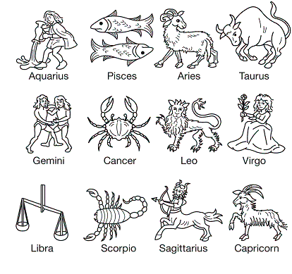

Astrology is an example of a pseudoscience. Why is it considered a pseudoscience, unlike astronomy, which is a science?

|  |  |
| --- | --- |
| A. | because it is based on the scientific method |
| B. | because it is not based on the scientific method |
| C. | because it can be easily replicated by other scientists |
| D. | because it was a much earlier science |

____ 11. Why is objectivity important to scientific investigations?

|  |  |
| --- | --- |
| A. | Objectivity means that the opinions of the scientist do not affect the results. |
| B. | Objectivity means that the opinions of the scientist are included in the results. |
| C. | Objectivity means that scientists repeat investigations; this makes the results more valid. |
| D. | Objectivity means that scientists add their own biases and beliefs to their data, which is important to obtaining valid conclusions. |

**Short Answer**

1. Evaluate the strengths and limits of science in terms of scope.

2. Explain how the work of scientists benefits our society as a whole.

**The Nature of Science: PSSA Prep**

**Answer Section**

**MULTIPLE CHOICE**

1. ANS: A

A is correct because pseudoscience deviates from the scientific method, but science does not.

B is incorrect because science is limited to phenomena people can observe.

C is incorrect because science systematically studies natural events and conditions.

D is incorrect because science uses a large body of empirical evidence to make explanations.

PTS: 1

DIF: Bloom's Traditional: Analysis | Bloom's Revised: Analyzing | Cognitive Complexity: Moderate | Depth of Knowledge 2: Basic Application of Skill | Student Level: Average

REF: 894604b0-fda6-11df-8e11-001e33aa91d2 OBJ: G8_NC_97990_WhatIsScience

TOP: Science and pseudoscience: Define pseudoscience.

KEY: science | pseudoscience | empirical evidence

MSC: Nature of Science | STEM | moduleK_u1_Lesson1 Quiz

2. ANS: D

A is incorrect because peer review is the process by which scientists validate or invalidate the work of other scientists.

B is incorrect because pseudoscience is the process of investigation that deviates from the scientific method.

C is incorrect because logical reasoning is the process by which people draw valid conclusions from true statements.

D is correct because empirical evidence is the cumulative body of observations that leads to a scientific explanation of a natural phenomenon.

PTS: 1

DIF: Bloom's Traditional: Comprehension | Bloom's Revised: Understanding | Cognitive Complexity: Low | Depth of Knowledge 1: Recall | Student Level: Basic

REF: 8948c3d0-fda6-11df-8e11-001e33aa91d2 OBJ: G8_NC_97990_WhatIsScience

TOP: Science and scientific explanations: Define science and empirical evidence.

KEY: empirical evidence | scientific data | scientific method

MSC: Nature of Science | STEM | moduleK_u1_Lesson1 Quiz

3. ANS: B

A is incorrect because the meaning of numbers beyond the mathematical sense cannot be tested or verified.

B is correct because a conclusion about a natural phenomenon is being supported by empirical evidence.

C is incorrect because finding water base on feeling an aura is an example of a pseudoscientific claim.

D is incorrect because predictions about the future based on the relative positions of heavenly bodies are examples of pseudoscientific claims.

PTS: 1

DIF: Bloom's Traditional: Evaluation | Bloom's Revised: Evaluating | Cognitive Complexity: High | Depth of Knowledge 3: Strategic Thinking | Student Level: Average

REF: 89534b20-fda6-11df-8e11-001e33aa91d2 OBJ: G8_NC_97990_WhatIsScience

TOP: Science and pseudoscience: Distinguish between scientific and pseudoscientific claims.

KEY: science | non-science | pseudoscience | scientific claim | pseudoscientific claim

MSC: Nature of Science | STEM | moduleK_u1_Lesson1 Quiz

4. ANS: A

A is correct because this statement does not have scientific backing from data or the scientific community.

B is incorrect because hundreds of scientists agreeing about a natural phenomenon is a major part of science.

C is incorrect because conclusions supported by numerous experiments are another component of science.

D is incorrect because conclusions supported by data are another component of science.

PTS: 1

DIF: Bloom's Traditional: Analysis | Bloom's Revised: Analyzing | Cognitive Complexity: Moderate | Depth of Knowledge 3: Strategic Thinking | Student Level: Average

REF: 89b23400-fda6-11df-8e11-001e33aa91d2 OBJ: G8_NC_97990_WhatIsScience

TOP: Science and pseudoscience: Distinguish between scientific and pseudoscientific claims.

KEY: science | pseudoscience MSC: Nature of Science | STEM | moduleK_u1 Unit Test A

5. ANS: B

A is incorrect because hundreds of scientists agreeing about a natural phenomenon is a major part of science.

B is correct because this belief is not supported by scientific evidence.

C is incorrect because conclusions supported by many are another component of science.

D is incorrect because conclusions supported by numerous experiments are another component of science.

PTS: 1

DIF: Bloom's Traditional: Analysis | Bloom's Revised: Analyzing | Cognitive Complexity: Moderate | Depth of Knowledge 3: Strategic Thinking | Student Level: Average

REF: 8b513e00-fda6-11df-8e11-001e33aa91d2 OBJ: G8_NC_97990_WhatIsScience

TOP: Science and pseudoscience: Distinguish between scientific and pseudoscientific claims.

KEY: science | pseudoscience MSC: Nature of Science | STEM | moduleK_u1 Unit Test B

6. ANS: D

A is incorrect because science involves the study of nonliving items, as well.

B is incorrect because science involves the observational study of the entire universe.

C is incorrect because science is based on systematic study and evidence, not on feelings and thoughts.

D is correct because science is the systematic study of natural events and conditions.

PTS: 1

DIF: Cognitive Complexity: Low | Student Level: Basic | Depth of Knowledge 1: Recall | Bloom's Traditional: Knowledge | Bloom's Revised: Remembering

REF: 7a3aca80-09ec-11e0-a95d-001e33aa91d2 OBJ: G8_NC_97990_WhatIsScience

TOP: Science and scientific explanations: Define science and empirical evidence.

KEY: science | nature MSC: Nature of Science | STEM | moduleK_u1 Pretest

7. ANS: B

A is incorrect because although pseudoscience resembles science, it does not follow scientific methods.

B is correct because pseudoscience does not follow scientific methods.

C is incorrect because pseudoscience resembles science, but does not follow scientific methods.

D is incorrect because pseudoscience resembles science.

PTS: 1

DIF: Cognitive Complexity: Low | Student Level: Basic | Depth of Knowledge 1: Recall | Bloom's Traditional: Knowledge | Bloom's Revised: Remembering

REF: 7a65f930-09ec-11e0-a95d-001e33aa91d2 OBJ: G8_NC_97990_WhatIsScience

TOP: Science and pseudoscience: Define pseudoscience.

KEY: science | pseudoscience | scientific method

MSC: Nature of Science | STEM | moduleK_Module Review

8. ANS: C

A is incorrect because the student is studying the effect of carbon dioxide, not the effects of watering and weather, on the plants.

B is incorrect because the student has already found plants for the investigation. Identifying other plants in other areas introduces other variables.

C is correct because a controlled experiment will allow the student to best isolate the effect of carbon dioxide.

D is incorrect because surveys of plant preferences does not add data or insight into a study of the effects of carbon dioxide on plant growth.

PTS: 1

DIF: Bloom's Traditional: Evaluation | Bloom's Revised: Evaluating | Cognitive Complexity: High | Depth of Knowledge 3: Strategic Thinking | Student Level: Advanced

REF: c1d37ef0-09ec-11e0-a95d-001e33aa91d2 OBJ: G8_NC_97990_WhatIsScience

TOP: Types of Scientific Investigations: Describe the relative benefits and limitations of experiments and other types of scientific investigations. KEY: scientific investigation | controlled experiment

MSC: Nature of Science | STEM | moduleK_u1 Pretest

9. ANS: D

A is incorrect because scientists must never allow personal bias or opinions to affect the nature of their work.

B is incorrect because a hypothesis offers a possible explanation, but a hypothesis is used to identify test variables and issues to be explored. The hypothesis itself does not support an explanation.

C is incorrect because imagination and originality because a hypothesis is used to identify test variables and issues to be explored. The hypothesis itself does not support an explanation.

D is correct because the data obtained from objective measurements can be used to reach a valid conclusion.

PTS: 1

DIF: Bloom's Traditional: Comprehension | Bloom's Revised: Understanding | Cognitive Complexity: Low | Depth of Knowledge 2: Basic Application of Skill | Student Level: Basic

REF: c1c91eb0-09ec-11e0-a95d-001e33aa91d2 OBJ: G8_NC_97990_WhatIsScience

TOP: Science and scientific explanations: Describe the nature of and evaluate scientific explanations.

KEY: science | scientist | experiment MSC: Nature of Science | STEM | moduleK_u1 Unit Test A

10. ANS: B

A is incorrect because astrology is not based on the scientific method.

B is correct because astrology, as a pseudoscience, is not based on the scientific method.

C is incorrect because astrology cannot be replicated by other scientists since it is not based on the scientific method and communicated among scientists in the traditional way.

D is incorrect because a pseudoscience can be developed at any time in history; the timing of the pseudoscience is unrelated to its practitioners not using the scientific method.

PTS: 1

DIF: Bloom's Traditional: Comprehension | Bloom's Revised: Understanding | Cognitive Complexity: Moderate | Depth of Knowledge 1: Recall | Student Level: Basic OBJ: G8_NC_97990_WhatIsScience

TOP: Science and pseudoscience: Distinguish between scientific and pseudoscientific claims.

KEY: nature of science | pseudoscience | scientific method | ethics | scientific method | science as a human endeavor MSC: moduleK_u1 Unit Review | Nature of Science | Uses visual element

11. ANS: A

A is correct because if scientists do not practice objectivity, their own personal biases can affect the investigation or its results.

B is incorrect because objectivity means keeping personal opinions out of scientific investigations.

C is incorrect because objectivity does not mean repeating investigations; objectivity means eliminating bias.

D is incorrect because objectivity requires eliminating bias, not adding bias.

PTS: 1

DIF: Bloom's Traditional: Comprehension | Bloom's Revised: Understanding | Cognitive Complexity: Low | Depth of Knowledge 1: Recall | Student Level: Basic

REF: 734340b0-fda6-11df-8e11-001e33aa91d2 OBJ: G8_NC_97990_WhatIsScience

TOP: Traits of scientists: List the traits people use when they engage in science, assessing how each aids in advancing science. KEY: bias | objectivity | investigation | scientist

MSC: Nature of Science

**SHORT ANSWER**

1. ANS:

Answers may vary. Answers should include some of the following points:

•    the idea that science is limited to phenomena people can observe, with or without instruments to aid observation

•    that scientific explanations are limited to those that can be tested and refuted by experimentation and observation

•    that any answer to a question in science requires reevaluation when new, relevant information emerges

PTS: 2

DIF: Bloom's Traditional: Evaluation | Bloom's Revised: Evaluating | Cognitive Complexity: High | Depth of Knowledge 4: Extended Thinking | Student Level: Advanced OBJ: G8_NC_97990_WhatIsScience

TOP: Science and scientific explanations: Evaluate the strengths and limits of science in terms of scope, topic, and explanations.

KEY: nature of science | scientific method | scope of science | scientific explanations | scientific method | conducting investigations | science as a human endeavor | identify questions that can be answered through scientific exploration | scientific explanations, laws, and theories

MSC: moduleK_u1 Unit Review | Nature of Science

2. ANS:

Answers may vary. Answers should include some of the following points:

•    that scientists work in many fields and thus can influence change in many different parts of society, any person who asks questions and looks for answers can be called a scientist (some scientists work in life science, earth science, physical science)

•    that scientists themselves come from many different backgrounds

•    that people in all walks of life use scientific principles to do their work in society

•    that scientific research has led to many life-saving discoveries, such as medicines, weather prediction, safer transport, and disease prevention, our ability to conserve and protect our resources

•    that new technology has improved human lives and changed the way humans think about the world

**Scientific Investigations: PSSA Prep**

**Multiple Choice**

*Identify the choice that best completes the statement or answers the question.*

____ 1. A researcher is trying to find information on the effects of computers on education. What source has the least validity?

|  |  |
| --- | --- |
| A. | a paper in a professional education journal written by a scientist |
| B. | a story in a magazine written by a technology teacher with 20 years of experience |
| C. | a newspaper article by a journalist who cites the work of an educational researcher |
| D. | an article on the Internet by a scientist who did one study and used a small sample size |

____ 2. Why might a scientist decide to do a laboratory experiment instead of fieldwork?

|  |  |
| --- | --- |
| A. | to include a larger number of variables |
| B. | to make observations under natural conditions |
| C. | to make observations in a controlled environment |
| D. | to have a smaller sample size to observe and experiment on |

____ 3. Scientific investigations include many different steps. After which step in a scientific investigation might a scientist use results to reject an existing hypothesis and form a new hypothesis?

|  |  |
| --- | --- |
| A. | defining a problem |
| B. | planning an investigation |
| C. | collecting and organizing data |
| D. | interpreting data and analyzing information |

____ 4. Adam’s hypothesis states that an object’s speed remains constant over time. Which data supports Adam’s hypothesis?

|  |  |
| --- | --- |
| A. |  |
| B. |  |
| C. |  |
| D. |  |

____ 5. There is no single way to conduct a scientific investigation. However, there are some techniques that are part of all good investigations. Which of the following is a characteristic of a poor scientific investigation?

|  |  |
| --- | --- |
| A. | A large sample size is used. |
| B. | The results cannot be replicated. |
| C. | The scientist keeps accurate records. |
| D. | Repeated trials have been conducted. |

____ 6. Scientific investigations involve many steps and processes. Which characteristics define a laboratory experiment?

|  |  |
| --- | --- |
| A. | hypothesis, models, and calculations |
| B. | test variables, data, and uncontrolled conditions |
| C. | data, conclusions, and unregulated environment |
| D. | independent and dependent variables, data, and controlled conditions |

____ 7. Scientists conduct many types of scientific investigations. Their efforts often include fieldwork, surveys, models, and experiments. Which statement about scientific investigations is **true**?

|  |  |
| --- | --- |
| A. | They rarely involve the collection of data under controlled conditions. |
| B. | They follow exactly the same steps because there is only one scientific method. |
| C. | They include multiple trials to increase the consistency of the data that are collected. |
| D. | Their primary focus seldom includes comparing or describing the unregulated world. |

____ 8. During several trials, a group of scientists tests the reaction of a new medicine on a strain of bacteria. Which step is essential for proving the validity of the results?

|  |  |
| --- | --- |
| A. | Make the process public so the results can be replicated. |
| B. | Change the procedure to check whether the same results take place. |
| C. | Have another scientist check to make sure the medicine was properly produced. |
| D. | Have each group member use a different medicine and see what happens when they test it on the bacteria. |

____ 9. New experimental data does not support a currently accepted hypothesis. Which course of action should the researcher take?

|  |  |
| --- | --- |
| A. | Do the experiment until the results support the hypothesis. |
| B. | Change the data to fit the hypothesis. |
| C. | Form a new hypothesis and plan a new experiment. |
| D. | Change the procedure to obtain the desired outcome. |

____ 10. There is no single correct way to conduct a scientific investigation. However, there are some techniques that are part of all good investigations. Which of the following is a characteristic of all good scientific investigations?

|  |  |
| --- | --- |
| A. | keeping accurate records |
| B. | working with other scientists |
| C. | using expensive scientific equipment |
| D. | conducting the investigation in a laboratory |

____ 11. A group of scientists wants to determine how members of a community view climate change. Which of the following would best accomplish this goal?

|  |  |
| --- | --- |
| A. | creating a model of the effects of climate change on an ecosystem |
| B. | taking a survey of a group of people about their opinions on climate change |
| C. | performing a laboratory experiment to replicate the effects of climate change |
| D. | conducting fieldwork to analyze the different gases that contribute to climate change |

____ 12. In which of the following examples would a scale model best be used?

|  |  |
| --- | --- |
| A. | to study organisms under natural conditions |
| B. | to collect data on different characteristics in a population |
| C. | to make exact measurements of an object using various pieces of equipment |
| D. | to develop an explanation for an object that is too large to be studied directly |

____ 13. Laboratory experiments allow scientists to make precise observations. Which one of the following is not a laboratory experiment?

|  |  |
| --- | --- |
| A. | counting the population of a country |
| B. | comparing the color of mold in three different Petri dishes |
| C. | measuring how much three plants grow with different amounts of light |
| D. | making observations about the impact of different kinds of fertilizer on seedlings growing near the windows in the lab |

____ 14. Which one of the following is not a characteristic of a good scientific investigation?

|  |  |
| --- | --- |
| A. | it can be replicated |
| B. | it is controlled |
| C. | it has a large sample size |
| D. | it has a very small sample size, making it easier for anyone to replicate it |

____ 15. Clara tests a hypothesis that the heavier of two materials will insulate cold drinks better than the lighter material. She adds equal volumes of the same cold drink to two different cup types. One cup type is made of lightweight plastic foam, and the other cup type is a heavier, ceramic material. Her sample size is five cups of each material. She records the average of her results in a chart.

|  |  |
| --- | --- |
| **Material** | **Time for beverage to warm to room temperature (hours)** |
| plastic foam | 3.25 |
| ceramic | 2.50 |

How are these experimental results valuable to Clara?

|  |  |
| --- | --- |
| A. | The results explain why the materials perform differently. |
| B. | The results did not support her hypothesis so she should form a new one. |
| C. | Clara can use a different heavier material to see if she obtains different results. |
| D. | The results can be communicated with others through newspapers, magazines, and the Internet to increase the validity of her results. |

____ 16. Deandra designs an experiment to test how far a rubber band stretches when objects of different masses are suspended from it. She records her data in a chart.

|  |  |  |  |
| --- | --- | --- | --- |
| **Mass (g)** | **Stretch (cm)** | **Mass (g)** | **Stretch (cm)** |
| **10** | **1** | **40** | **4** |
| **20** | **2** | **50** | **4.8** |
| **30** | **3** | **60** | **5.5** |

Which variable is independent?

|  |  |
| --- | --- |
| A. | Band type |
| B. | Stretch |
| C. | Time |
| D. | Mass |

____ 17. A student is conducting an experiment on the rate of cooling. She hypothesizes that objects cool at a constant rate. After conducting an experiment, she makes the following graph to display her results.

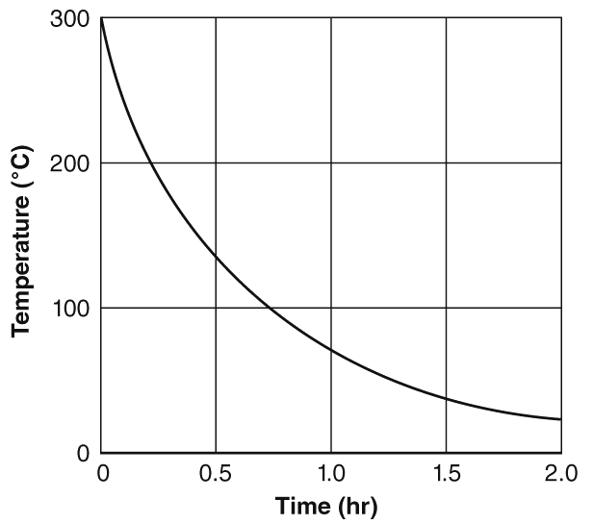

Which of the following statements best describes the student’s experiment?

|  |  |
| --- | --- |
| A. | The experiment supports the hypothesis. |
| B. | The experiment had too many variables to be able to prove the hypothesis. |
| C. | The experiment does not support the hypothesis, but it does show that a different scientific explanation is possible. |
| D. | The experiment does not support the hypothesis, and there is not a defensible scientific explanation to explain the results of the experiment. |

____ 18. A student is conducting an investigation to see how high into the air different sizes of rubber bands will travel when stretched and released. When she examines the data, she realizes that rubber band A was stretched and released only once, while the other sizes were stretched and released five times. What should the student do with the data from rubber band A?

|  |  |
| --- | --- |
| A. | The data from the trial with rubber band A is as relevant as the data from the trials with the other rubber bands. This data should be included in her conclusion. |
| B. | The data from the trial with rubber band A is more useful and relevant than the data from the trials with the other rubber bands. She should use only this data in her conclusion. |
| C. | The data from the trial with rubber band A is not relevant because the trials with rubber band A were not repeated. She should repeat the trial four more times before including the data in her conclusion. |
| D. | The data from the trial with rubber band A is not relevant because rubber band A was a different size than the other rubber bands. She should include in her conclusions only data from rubber bands of the same size. |

**Short Answer**

1. Using an example, explain the difference between a hypothesis and a prediction.

**Essay**

1. Shakira predicts that hot metal objects do not cool at a constant rate. She experiments by heating a metal object and then allows it to cool to room temperature. She measures the temperature of the metal with a thermometer every half hour, and she carefully records her results in her notebook. From her temperature data, she draws the following graph.



Based on the graph, was Shakira’s prediction supported or not supported? Explain how you know.

___________________________________________________

___________________________________________________

What could Shakira do to make sure her results are replicable?

___________________________________________________

___________________________________________________

Shakira learns that the cooling system turned on approximately one hour after the experiment began. Explain how this could have affected the experiment and what Shakira should do to prevent this from happening in the future.

___________________________________________________

___________________________________________________

___________________________________________________

2. Shakira predicts that hot metal objects cool at constant rates. She experiments by heating a metal object with a Bunsen burner and then allowing it to cool to room temperature. She measures the temperature of the metal every half hour, and she carefully records her results in her notebook. From her temperature data, she draws the following graph.



What tool should Shakira use to collect quantitative data during her experiment?

___________________________________________________

Based on the graph, was Shakira’s prediction supported or not supported? Explain how you know.

___________________________________________________

___________________________________________________

What could Shakira do to make sure her results are replicable?

___________________________________________________

___________________________________________________

Shakira learns that the heating and air conditioning system turned on at around one hour after the experiment began. Explain whether this could affect the experiment and what Shakira should do.

___________________________________________________

___________________________________________________

___________________________________________________

**Other**

1. A(n) ____________________ is an organized procedure to study something under controlled conditions.

2. Scientists collect and record ____________________.

3. A(n) ____________________ is deliberately changed in a scientific study.

**Scientific Investigations: PSSA Prep**

**Answer Section**

**MULTIPLE CHOICE**

1. ANS: D

A is incorrect because a paper in a professional education journal has the most validity.

B is incorrect because a story in a magazine might lack some validity, but the experience of the teacher makes it credible, and it has more validity than a scientist who does one study and uses a small sample size.

C is incorrect because a journalist is citing the work of an educational researcher, which has a measure of validity.

D is correct because a small sample size and one study is not enough to make a valid conclusion.

PTS: 1

DIF: Bloom's Traditional: Analysis | Bloom's Revised: Analyzing | Cognitive Complexity: Moderate | Depth of Knowledge 3: Strategic Thinking | Student Level: Average

REF: 89617bf0-fda6-11df-8e11-001e33aa91d2

OBJ: G8_NC_87010_ScientificInvestigation

TOP: Characteristics of Good Scientific Investigations: Evaluate the quality of scientific information from different sources. KEY: investigation | valid | credible | science

MSC: Nature of Science | STEM | moduleK_u1_Lesson2 Quiz

2. ANS: C

A is incorrect because a scientist would choose the lab to have fewer variables to study.

B is incorrect because a scientist would choose fieldwork, not a lab, to make observations under natural conditions.

C is correct because a scientist would choose the lab to have a more controlled environment.

D is incorrect because a scientist would not have a good experiment if the sample size was small, and thus would not need the lab to have a smaller sample size.

PTS: 1

DIF: Bloom's Traditional: Comprehension | Bloom's Revised: Understanding | Cognitive Complexity: Low | Depth of Knowledge 2: Basic Application of Skill | Student Level: Basic

REF: 8964b040-fda6-11df-8e11-001e33aa91d2

OBJ: G8_NC_87010_ScientificInvestigation

TOP: Types of Scientific Investigations: Describe the relative benefits and limitations of experiments and other types of scientific investigations. KEY: scientific investigation | fieldwork

MSC: Nature of Science | STEM | moduleK_u1_Lesson2 Quiz

3. ANS: D

A is incorrect because a hypothesis is modified, or formed, after the interpretation and organization of data or information.

B is incorrect because a hypothesis is modified, or formed, after the interpretation and organization of data or information.

C is incorrect because a hypothesis is modified, or formed, after the interpretation and organization of data or information.

D is correct because a hypothesis is modified, or formed, after the interpretation and organization of data or information.

PTS: 1

DIF: Bloom's Traditional: Analysis | Bloom's Revised: Analyzing | Cognitive Complexity: Moderate | Depth of Knowledge 3: Strategic Thinking | Student Level: Average

REF: 8b4e09b0-fda6-11df-8e11-001e33aa91d2

OBJ: G8_NC_87010_ScientificInvestigation

TOP: Conducting a Scientific Experiment: Explain the major processes involved in conducting a scientific investigation. KEY: data analysis | scientific method | hypothesis

MSC: Nature of Science | STEM

4. ANS: A

A is correct because the graph shows a constant speed, which supports the hypothesis.

B is incorrect because the graph shows a constant increase in speed, which does not support the hypothesis.

C is incorrect because the graph shows a constant decrease in speed, which does not support the hypothesis.

D is incorrect because the graph shows a variable increase in speed, which does not support the hypothesis.

PTS: 1

DIF: Cognitive Complexity: Moderate | Student Level: Average | Depth of Knowledge 2: Basic Application of Skill | Bloom's Traditional: Evaluation | Bloom's Revised: Evaluating

REF: 7a689140-09ec-11e0-a95d-001e33aa91d2

OBJ: G8_NC_87010_ScientificInvestigation

TOP: Conducting a Scientific Experiment: Explain the major processes involved in conducting a scientific investigation. KEY: hypothesis | graph | speed

MSC: Uses visual element | Nature of Science | STEM | moduleK_u1 Unit Test A

5. ANS: B

A is incorrect because a good scientific investigation would have a large sample size.

B is correct because if the results of a scientific investigation cannot be replicated, the investigation may be flawed.

C is incorrect because keeping accurate records is part of a good scientific investigation.

D is incorrect because repeating trials is part of a good scientific investigation.

PTS: 1

DIF: Bloom's Traditional: Comprehension | Bloom's Revised: Understanding | Cognitive Complexity: Low | Depth of Knowledge 2: Basic Application of Skill | Student Level: Basic

REF: 8b3d67e0-fda6-11df-8e11-001e33aa91d2

OBJ: G8_NC_87010_ScientificInvestigation

TOP: Characteristics of Good Scientific Investigations: List some characteristics of good scientific investigations. KEY: good investigation | science

MSC: Nature of Science | STEM | moduleK_u1 Unit Test B

6. ANS: D

A is incorrect because not all lab experiments involve models.

B is incorrect because lab experiments do not involve uncontrolled conditions.

C is incorrect because lab experiments do not take place in unregulated environments.

D is correct because lab experiments must include all of these characteristics.

PTS: 1

DIF: Cognitive Complexity: Low | Student Level: Basic | Depth of Knowledge 1: Recall | Bloom's Traditional: Knowledge | Bloom's Revised: Remembering

REF: 7a914ef0-09ec-11e0-a95d-001e33aa91d2

OBJ: G8_NC_87010_ScientificInvestigation

TOP: Types of Scientific Investigations: Define experiment.

KEY: laboratory experiment | controlled condition | dependent variable | independent variable

MSC: Nature of Science | STEM | moduleK_u1_Lesson2 Quiz

7. ANS: C

A is incorrect because scientists do conduct experiments under controlled conditions.

B is incorrect because there is more than one scientifically based method for conducting investigations.

C is correct because investigations often do include multiple trials.

D is incorrect because many investigations focus on exploring unregulated surroundings.

PTS: 1

DIF: Cognitive Complexity: Low | Student Level: Average | Depth of Knowledge 2: Basic Application of Skill | Bloom's Traditional: Evaluation | Bloom's Revised: Evaluating

REF: 7a31f0e0-09ec-11e0-a95d-001e33aa91d2

OBJ: G8_NC_87010_ScientificInvestigation

TOP: Characteristics of Good Scientific Investigations: List some characteristics of good scientific investigations. KEY: scientific method | repetition | controlled condition

MSC: Nature of Science | STEM | moduleK_u1 Pretest

8. ANS: A

A is correct because having other scientists perform the experiment will determine if it can be replicated and happen with frequency.

B is incorrect because if the scientists change the procedure, they cannot be sure if the conditions of the first procedure are replicated by the second procedure.

C is incorrect because it does not check the validity of the experiment.

D is incorrect because this step tests how the medicines react to the bacteria but does not test the validity of the original experiment.

PTS: 1

DIF: Cognitive Complexity: Low | Student Level: Basic | Depth of Knowledge 1: Recall | Bloom's Traditional: Knowledge | Bloom's Revised: Remembering

REF: 7a4e5280-09ec-11e0-a95d-001e33aa91d2

OBJ: G8_NC_87010_ScientificInvestigation

TOP: Characteristics of Good Scientific Investigations: List some characteristics of good scientific investigations. KEY: repetition | replication | equipment | procedure

MSC: Nature of Science | STEM | moduleK_Module Review

9. ANS: C

A is incorrect because the results are not valid, so forming a new hypothesis and planning a new experiment would be the correct procedure.

B is incorrect because changing data is unethical and does not produce valid results.

C is correct because the researcher needs a new hypothesis and a new plan for investigating the new hypothesis.

D is incorrect because an experimental procedure must be reproducible and cannot be altered from one trial to the next.

PTS: 1

DIF: Cognitive Complexity: Low | Student Level: Average | Depth of Knowledge 2: Basic Application of Skill | Bloom's Traditional: Comprehension | Bloom's Revised: Understanding

REF: 7a9f7fc0-09ec-11e0-a95d-001e33aa91d2

OBJ: G8_NC_87010_ScientificInvestigation

TOP: Conducting a Scientific Experiment: Explain the major processes involved in conducting a scientific investigation. KEY: scientific method | hypothesis | supporting evidence

MSC: Nature of Science | STEM | moduleK_u1_Lesson2 Quiz

10. ANS: A

A is correct because all scientific investigations require keeping accurate records.

B is incorrect because scientists may work together or separately while investigating.

C is incorrect because some investigations may use very simple and inexpensive equipment. The equipment should fit the purpose and procedure of the investigation.

D is incorrect because some investigations are done in the field or outside of the laboratory. Laboratories offer good opportunities for controlling variables, but may not be the best places for investigations if the goal is to study an organism in its natural environment or many other situations.

PTS: 1

DIF: Cognitive Complexity: Low | Student Level: Average | Depth of Knowledge 2: Basic Application of Skill | Bloom's Traditional: Comprehension | Bloom's Revised: Understanding

REF: 7a6e3690-09ec-11e0-a95d-001e33aa91d2

OBJ: G8_NC_87010_ScientificInvestigation

TOP: Characteristics of Good Scientific Investigations: List some characteristics of good scientific investigations. KEY: scientific investigation | accuracy | scientific method

MSC: Nature of Science | STEM | moduleK_u1 Unit Test A

11. ANS: B

A is incorrect because a model of an ecosystem does not show how people view climate change.

B is correct because a survey would be able to determine people’s views about climate change.

C is incorrect because a laboratory experiment on the effects of climate change does not address the way people view climate change.

D is incorrect because conducting fieldwork on gases does not address the way people view climate change.

PTS: 1

DIF: Bloom's Traditional: Analysis | Bloom's Revised: Analyzing | Cognitive Complexity: Moderate | Depth of Knowledge 3: Strategic Thinking | Student Level: Average

REF: 7a22d5b0-09ec-11e0-a95d-001e33aa91d2

OBJ: G8_NC_87010_ScientificInvestigation

TOP: Types of Scientific Investigations: Describe the relative benefits and limitations of experiments and other types of scientific investigations. | Types of Scientific Investigations: Differentiate between experiments and other scientific investigations. KEY: scientific method | scientific investigation | survey

MSC: Nature of Science | STEM | moduleK_u1 Unit Test B

12. ANS: D

A is incorrect because a scale model is not a real organism, therefore a scale model will not interact with its environment and conditions as the real organism would.

B is incorrect because a scale model is not a real organism or population of organisms, therefore a scale model will not interact with its environment and conditions as the real organism or population of organisms would.

C is incorrect because exact measurements are best made on the object itself. A scale model is based on measurements that have been made on the object.

D is correct because scale models are appropriate for studying objects that cannot be studied directly, such as those that are too large, too small, or too dangerous to be studied directly.

PTS: 1

DIF: Bloom's Traditional: Comprehension | Bloom's Revised: Understanding | Cognitive Complexity: Low | Depth of Knowledge 2: Basic Application of Skill | Student Level: Basic

REF: c1cfd570-09ec-11e0-a95d-001e33aa91d2

OBJ: G8_NC_87010_ScientificInvestigation

TOP: Types of Scientific Investigations: Describe the relative benefits and limitations of experiments and other types of scientific investigations. | Types of Scientific Investigations: Differentiate between experiments and other scientific investigations. KEY: laboratory experiment | model

MSC: Nature of Science | STEM | moduleK_u1 Unit Test A

13. ANS: A

A is correct because even though a census count gathers data, it is not controlled or precise, or carried out in a laboratory.

B is incorrect because this type of experiment would be very controlled in a laboratory environment.

C is incorrect because the amount of light is an independent variable, or something that an observer would control or change within the lab.

D is incorrect because the experiment is taking place within a controlled lab environment.

PTS: 1

DIF: Bloom's Traditional: Application | Bloom's Revised: Analyzing | Cognitive Complexity: Moderate | Depth of Knowledge 2: Basic Application of Skill | Student Level: Average

OBJ: G6_NC_87010_ScientificInvestigation

TOP: Types of Scientific Investigations: Differentiate between experiments and other scientific investigations.

KEY: experiment | nature of science | scientific investigation | observation | scientific method | conducting investigations | science as a human endeavor

MSC: moduleK_u1 Unit Review | Nature of Science

14. ANS: D

A is incorrect because good scientific investigations can be replicated.

B is incorrect because control is a part of sound scientific investigations that test specific variables.

C is incorrect because large sample sizes are considered important for sound investigations.

D is correct because a small sample size might not provide an accurate picture of real relationships.

PTS: 1

DIF: Bloom's Traditional: Application | Bloom's Revised: Understanding | Cognitive Complexity: Moderate | Depth of Knowledge 2: Basic Application of Skill | Student Level: Average

OBJ: G6_NC_87010_ScientificInvestigation

TOP: Characteristics of Good Scientific Investigations: List some characteristics of good scientific investigations.

KEY: control | investigation | sample size | replication | design process | scientific method | ethics

MSC: moduleK_u1 Unit Review | Nature of Science

15. ANS: B

A is incorrect because the results simply tell us that Clara’s hypothesis was wrong, not necessarily why the materials performed differently.

B is correct because Clara’s hypothesis was wrong, so she learned that the heavier of two materials will not keep the drink colder.

C is incorrect because Clara now knows that a heavier material will be a less effective insulator. She could instead investigate lighter materials for their insulating qualities.

D is incorrect because the results will not become more valid if Clara communicates the results to others.

PTS: 1

DIF: Bloom's Traditional: Comprehension | Bloom's Revised: Applying | Cognitive Complexity: Moderate | Depth of Knowledge 2: Basic Application of Skill | Student Level: Average

OBJ: G6_NC_87010_ScientificInvestigation

TOP: Characteristics of Good Scientific Investigations: Evaluate the quality of scientific information from different sources.

KEY: hypothesis | experiment | result | scientific method | scientific method | conducting investigations | hypotheses, conclusions

MSC: moduleK_u1 Unit Review | Nature of Science | Uses visual element

16. ANS: D

A is incorrect because the bands are all the same type.

B is incorrect because the same type of bands are used in this experiment, and their stretch is the change that results from the manipulation of the mass. This makes the stretch distance the dependent variable.

C is incorrect because time is not a variable at all in this experiment.

D is correct because the mass of the object stretching the bands is the variable that is being changed or manipulated.

PTS: 1

DIF: Bloom's Traditional: Evaluation | Bloom's Revised: Evaluating | Cognitive Complexity: Moderate | Depth of Knowledge 2: Basic Application of Skill | Student Level: Average

OBJ: G6_NC_87010_ScientificInvestigation

TOP: Conducting a Scientific Experiment: Define hypothesis, independent variable, dependent variable, observation, and data. | Conducting a Scientific Experiment: Explain the major processes involved in conducting a scientific investigation.

KEY: variable | scientific method | independent variable | dependent variable | scientific method | interpreting visual elements such as tables, graphs, and diagrams | conducting investigations | data, measurement, units

MSC: moduleK_u1 Unit Review | Nature of Science | Uses visual element

17. ANS: C

A is incorrect because if the temperature cooled at a constant rate, the graph should show a downward-sloping straight (not curved) line.

B is incorrect because neither the question nor the graph shows the variables that were part of the experiment; this information cannot be determined from the question.

C is correct because though the experiment does not support the hypothesis, it is possible that the experiment could support a different hypothesis. The student could revise the hypothesis and retest it in a new experiment.

D is incorrect because this graph shows temperature decreasing as time decreases; a new experiment could be devised to test hypotheses related to this explanation.

PTS: 1

DIF: Bloom's Traditional: Analysis | Bloom's Revised: Analyzing | Cognitive Complexity: Moderate | Depth of Knowledge 3: Strategic Thinking | Student Level: Average

REF: 7330ca20-fda6-11df-8e11-001e33aa91d2

OBJ: G6_NC_87010_ScientificInvestigation

TOP: Conducting a Scientific Experiment: Explain the major processes involved in conducting a scientific investigation. KEY: hypothesis | experiment | graph

MSC: Uses visual element | Nature of Science

18. ANS: C

A is incorrect because data is more useful and relevant when it comes from repeated trials. The data from rubber band A is less useful because the trials were not repeated.

B is incorrect because the data from the trial with rubber band A is less useful, not more useful, than the data from trials that were repeated.

C is correct because data is more relevant when it comes from repeated trials. The student should repeat the trials to collect more data about rubber band A before including the data in her conclusion.

D is incorrect because the data is less relevant because the trials were not repeated, not because the rubber band was a different size.

PTS: 1

DIF: Bloom's Traditional: Evaluation | Bloom's Revised: Evaluating | Depth of Knowledge 3: Strategic Thinking | Cognitive Complexity: High | Student Level: Advanced

REF: 73403370-fda6-11df-8e11-001e33aa91d2

OBJ: G6_NC_87010_ScientificInvestigation

TOP: Characteristics of Good Scientific Investigations: List some characteristics of good scientific investigations. KEY: data | investigation | useful | relevant

MSC: Nature of Science

**SHORT ANSWER**

1. ANS:

Answers may vary. Answers should include some of the following points:

•    that a hypothesis is a testable idea or explanation that leads to scientific explanations of phenomena

•    that a prediction shows a cause and effect relationship

•    that the difference between a hypothesis and a prediction is that a hypothesis offers an explanation, and a prediction shows the cause and effect relationship

•    an example of a hypothesis might be the statement “water mixed with manure will make the plant grow taller than the plain tap water”

•    an example of a prediction might be the statement: “feeding manure to plants causes the plants to grow taller than plants that are not fed manure”

PTS: 2

DIF: Bloom's Traditional: Application | Bloom's Revised: Applying | Cognitive Complexity: Moderate | Depth of Knowledge 2: Basic Application of Skill | Student Level: Average

OBJ: G6_NC_87010_ScientificInvestigation

TOP: Conducting a Scientific Experiment: Define hypothesis, independent variable, dependent variable, observation, and data.

KEY: scientific method | hypothesis | prediction | conducting investigations | identify questions that can be answered through scientific exploration | scientific method | conducting investigations | hypothesis, conclusions MSC: moduleK_u1 Unit Review | Nature of Science

**ESSAY**

1. ANS:

**•** yes, plus supporting data from the graph to explain why the change is not constant (e.g., *Data from the graph shows that the change is not constant. In the first half hour, the temperature dropped about 170°C, but the temperature only decreased by about 60°C in the second half hour*; etc.)

**•** explanation of how Shakira could replicate her results (e.g., *Shakira should keep careful notes of her procedure so that she and other investigators can repeat her experiment*; etc.)

**•** explanation of how the cooling system could affect the experiment and how to avoid this problem (e.g., *The temperature within the laboratory is a variable that could affect the outcome of the experiment. Shakira should note the error in her experimental notes, then repeat the experiment. When she repeats the experiment, she should control the room temperature*; etc.)

PTS: 4

DIF: Cognitive Complexity: High | Student Level: Advanced | Depth of Knowledge 3: Strategic Thinking | Bloom's Traditional: Evaluation | Bloom's Revised: Evaluating

REF: 8b678520-fda6-11df-8e11-001e33aa91d2

OBJ: G8_NC_87010_ScientificInvestigation

TOP: Conducting a Scientific Experiment: Explain the major processes involved in conducting a scientific investigation. KEY: hypothesis | data | tool | multiple trial | consistent result

MSC: Uses visual element | Nature of Science | STEM | moduleK_u1 Unit Test A

2. ANS:

**•** thermometer

**•** yes, plus supporting data from the graph to explain why the change is not constant (e.g., *In the first half hour, the temperature dropped about 170°C, but the temperature only decreased by about 60°C in the second half hour*; etc.)

**•** description of how Shakira could replicate her results (e.g., *Shakira could repeat her experiment; run multiple trials; ask others to attempt to repeat the experiment*; etc.)

**•** explanation of how the cooling system could affect the experiment and how to avoid this problem (e.g., *The temperature within the laboratory is a variable that could affect the outcome of the experiment. Shakira should note the error in her experimental notes, then repeat the experiment. When she repeats the experiment, she should control the room temperature*; etc.)

PTS: 4

DIF: Cognitive Complexity: High | Student Level: Advanced | Depth of Knowledge 3: Strategic Thinking | Bloom's Traditional: Evaluation | Bloom's Revised: Evaluating

REF: 9044ca30-fda6-11df-8e11-001e33aa91d2

OBJ: G8_NC_87010_ScientificInvestigation

TOP: Conducting a Scientific Experiment: Explain the major processes involved in conducting a scientific investigation. KEY: hypothesis | data | tool | multiple trial | consistent result

MSC: Nature of Science | STEM | moduleK_u1 Unit Test B | Uses visual element

**OTHER**

1. ANS:

Rationale: Experiments are usually conducted in regulated conditions.

PTS: 2

DIF: Bloom's Traditional: Comprehension | Bloom's Revised: Understanding | Cognitive Complexity: Moderate | Depth of Knowledge 1: Recall | Student Level: Basic

OBJ: G6_NC_87010_ScientificInvestigation

TOP: Types of Scientific Investigations: Define experiment.

KEY: experiment | investigation | nature of science

MSC: moduleK_u1 Unit Review | Nature of Science

2. ANS:

Rationale: Data are information gathered by observation or experimentation that can be used in calculating or reasoning.

PTS: 2

DIF: Bloom's Traditional: Knowledge | Bloom's Revised: Remembering | Cognitive Complexity: Low | Depth of Knowledge 1: Recall | Student Level: Basic

OBJ: G6_NC_87010_ScientificInvestigation

TOP: Conducting a Scientific Experiment: Define hypothesis, variable, observation, and data.

KEY: science | data MSC: moduleK_u1 Unit Review | Nature of Science

3. ANS:

Rationale: Manipulation of the independent variable, or the factors being investigated, lead to changes in the investigation’s dependent variable, or outcome.

PTS: 2

DIF: Bloom's Traditional: Application | Bloom's Revised: Applying | Cognitive Complexity: Moderate | Depth of Knowledge 2: Basic Application of Skill | Student Level: Average

OBJ: G6_NC_87010_ScientificInvestigation

TOP: Conducting a Scientific Experiment: Define hypothesis, independent variable, dependent variable, observation, and data.

KEY: independent variable | conducting experiments | scientific method | scientific method | conducting investigations | identify questions that can be answered through scientific exploration | science as a human endeavor MSC: moduleK_u1 Unit Review | Nature of Science

**Scientific Knowledge: PSSA Prep**

**Multiple Choice**

*Identify the choice that best completes the statement or answers the question.*

____ 1. Which statement describes how a scientist makes scientific explanations?

|  |  |
| --- | --- |
| A. | A scientist bases scientific explanations on a large body of observations of the world. |
| B. | A scientist bases scientific explanations only on other scientists’ opinions. |
| C. | A scientist bases scientific explanations on personal experience and opinions. |
| D. | A scientist suggests scientific explanations and makes up evidence to make them true. |

____ 2. Which of these answers best describes a scientific theory?

|  |  |
| --- | --- |
| A. | an explanation based on the opinion of a scientist |
| B. | a well-supported and widely accepted explanation of nature |
| C. | a description of a specific relationship under given conditions |
| D. | a statement describing what always happens under certain conditions |

____ 3. Which of these scientists would most likely engage in fieldwork to observe organisms?

|  |  |
| --- | --- |
| A. | chemist |
| B. | biologist |
| C. | physicist |
| D. | mathematician |

____ 4. Ricardo was volunteering at a library. The librarian asked him to help clean the research area. Ricardo found the map shown below in a stack of papers.

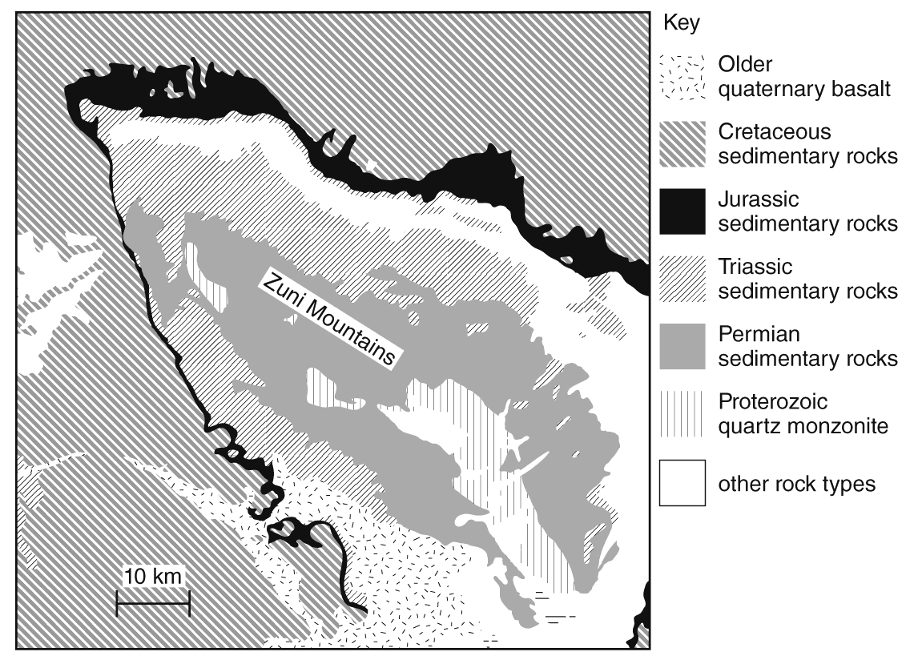

The librarian told Ricardo that some scientists use a map such as this one. Which type of scientist **most** **likely** uses this map?

|  |  |
| --- | --- |
| A. | chemist |
| B. | biologist |
| C. | geologist |
| D. | physicist |

____ 5. Which of these events might lead to the modification of a scientific idea?

|  |  |
| --- | --- |
| A. | A scientist uses a computer to teach a scientific concept to students. |
| B. | Two scientists doing the same experiment in different parts of the world under the same conditions get the same results. |
| C. | One scientist finds evidence that she feels doesn’t fit a theory. Other scientists agree that her results are valid. |
| D. | A scientist performs an experiment and finds out that one of the chemicals used in the experiment was contaminated. |

____ 6. The figure below shows a concept related to the kinetic theory of matter, which describes the behavior of gases based on the motion of the particles.

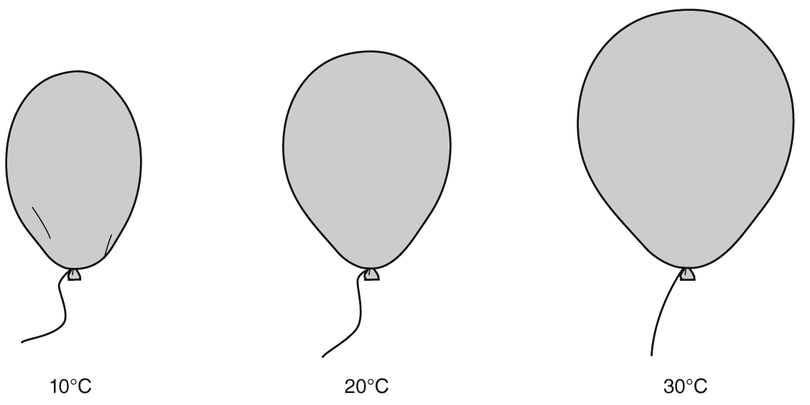

How would the kinetic theory explain what is happening in the above example?

|  |  |
| --- | --- |
| A. | The balloon gets bigger as the temperature of the gas inside it decreases, because the gas particles move faster and get farther apart. |
| B. | The balloon gets smaller as the temperature of the gas inside it decreases, because the gas particles begin to escape from the balloon. |
| C. | The balloon gets bigger as the temperature of the gas inside it increases, because the gas particles move faster and get farther apart. |
| D. | The balloon gets smaller as the temperature of the gas inside it increases, because the gas particles move more slowly and get closer together. |

____ 7. Which of the following is a scientific law?

|  |  |
| --- | --- |
| A. | Climate is changing due to human activities. |
| B. | Microorganisms are the cause of many illnesses. |
| C. | Tectonic plates move because of a flexible layer beneath Earth. |
| D. | Any two objects exert a gravitational force of attraction on each other. |

____ 8. What term best describes the following statement?

“Any two objects exert a gravitational force of attraction on each other.”

|  |  |
| --- | --- |
| A. | a scientific law |
| B. | a scientific theory |
| C. | a scientific hypothesis |
| D. | a scientific observation |

____ 9. Kathleen made the diagram below to show how scientific knowledge changes over time. Which word or phrase best describes what scientists would do at the point indicated by the blank?

original idea + ?  modified idea

|  |  |
| --- | --- |
| A. | new evidence |
| B. | form an opinion |
| C. | change the data |
| D. | design an experiment |

____ 10. Diep did some research about classification for a science report. She learned that until 150 years ago, scientists recognized only two groups of organisms: plants and animals. Now, scientists also recognize several groups of microscopic organisms. How should Diep explain why scientists decided to classify organisms into more groups?

|  |  |
| --- | --- |
| A. | More types of organisms exist now than before. |
| B. | Fewer organisms have gone extinct in recent years. |
| C. | Scientists continue to learn more about living organisms. |
| D. | Scientists invent new organisms that need to be classified. |

____ 11. What is the description of a specific relationship under given conditions in the natural world known as?

|  |  |
| --- | --- |
| A. | a tenet of science |
| B. | a scientific law |
| C. | a theory |
| D. | a hypothesis |

____ 12. After many investigations, Dr. Grossman, a geologist, developed an idea about why certain rocks are found in the Rocky Mountains of North America. Many other geologists accept Dr. Grossman’s findings and ideas about why these rocks are present in the Rocky Mountains. What has Dr. Grossman developed?

|  |  |
| --- | --- |
| A. | a law |
| B. | a theory |
| C. | a set of facts |
| D. | a hypothesis |

____ 13. Consider the history of the theory of atoms. How does this history help explain why it is important to analyze and evaluate scientific explanations?

|  |  |
| --- | --- |
| A. | Studies of the atom show that old scientific theories are always wrong and always need to be revised. |
| B. | Scientific knowledge of the atom has increased, so scientific explanations have changed to reflect new evidence. |
| C. | Studies of the atom do not support the idea that it is important to analyze and evaluate scientific explanations. |
| D. | The modern theory of the atom is the same as the original theories about the atom; therefore, it’s not important to analyze and evaluate scientific explanations. |

____ 14. How is empirical evidence related to scientific explanations?

|  |  |
| --- | --- |
| A. | Empirical evidence is not related to scientific explanations. |
| B. | Empirical evidence is the same thing as a scientific explanation. |
| C. | Empirical evidence includes detailed observations which help scientists evaluate scientific explanations. |
| D. | Empirical evidence includes opinions about natural phenomena which help scientists evaluate scientific explanation. |

**Short Answer**

1. After the results of one experiment, a scientist decides that a long-held scientific theory must be revised. Describe what must be done first before the scientific theory is changed.

___________________________________________________

___________________________________________________

___________________________________________________

___________________________________________________

**Other**

1. A scientific ____________________ is a well-supported and widely accepted explanation of a natural occurrence.

**Scientific Knowledge: PSSA Prep**

**Answer Section**

**MULTIPLE CHOICE**

1. ANS: A

A is correct because empirical evidence is the cumulative body of explanations of a natural phenomenon.

B is incorrect because empirical evidence is not based on opinion.

C is incorrect because these are subjective, not objective like empirical evidence is.

D is incorrect because scientists cannot make up evidence to support a scientific investigation.

PTS: 1

DIF: Cognitive Complexity: Low | Depth of Knowledge 1: Recall | Student Level: Average | Bloom's Traditional: Comprehension | Bloom's Revised: Understanding

REF: 7aa28d00-09ec-11e0-a95d-001e33aa91d2

OBJ: G7_NC_77280_ScientificKnowledge

TOP: The Nature of Science and Empirical Evidence: Define empirical evidence.

KEY: empirical evidence | observation | scientific explanation

MSC: Nature of Science | STEM | moduleK_u1_Lesson3 Quiz

2. ANS: B

A is incorrect because scientific laws are not based on opinion.

B is correct because a scientific theory is an explanation that ties together various observations and facts.

C is incorrect because the statement describes a scientific law.

D is incorrect because a law, not a theory, describes what always happens under certain conditions.

PTS: 1

DIF: Cognitive Complexity: Low | Depth of Knowledge 1: Recall | Student Level: Basic | Bloom's Traditional: Knowledge | Bloom's Revised: Remembering

REF: 7a37bd40-09ec-11e0-a95d-001e33aa91d2

OBJ: G7_NC_77280_ScientificKnowledge TOP: Theory vs. Law: Define theory.

KEY: scientific theory | scientific law MSC: Nature of Science | STEM | moduleK_u1 Pretest

3. ANS: B

A is incorrect because chemists are less likely to be in the field observing organisms.

B is correct because some biologists frequently work in the field to observe organisms.

C is incorrect because physicists are less likely to be in the field observing organisms.

D is incorrect because mathematicians rarely perform fieldwork to gather information. They use computers, surveys, and calculations.

PTS: 1

DIF: Cognitive Complexity: Low | Depth of Knowledge 1: Recall | Student Level: Basic | Bloom's Traditional: Knowledge | Bloom's Revised: Remembering

REF: 7aa63680-09ec-11e0-a95d-001e33aa91d2

OBJ: G7_NC_77280_ScientificKnowledge

TOP: The Nature of Science and Empirical Evidence: Describe the methods used to gain empirical evidence and pursue scientific explanations in different fields of science: biology, geology, and physics.

KEY: fieldwork | biologist | evidence MSC: Nature of Science | STEM | moduleK_u1_Lesson3 Quiz

4. ANS: C

A is incorrect because the map shows a mountain range and rock types, which are features that geologists generally study.

B is incorrect because the map describes a mountain range and rock types, not information about living things, so it would more likely be used by a geologist rather than a biologist.

C is correct because the map shown is a geologic map, a tool used by geologists.

D is incorrect because physicists generally do not use maps of Earth’s features.

PTS: 1

DIF: Cognitive Complexity: Low | Depth of Knowledge 2: Basic Application of Skill | Student Level: Basic | Bloom's Traditional: Application | Bloom's Revised: Applying

REF: 7a74c640-09ec-11e0-a95d-001e33aa91d2

OBJ: G7_NC_77280_ScientificKnowledge

TOP: The Nature of Science and Empirical Evidence: Describe the methods used to gain empirical evidence and pursue scientific explanations in different fields of science: biology, geology, and physics.

KEY: geologist | geologic map | geology

MSC: Nature of Science | STEM | moduleK_u1 Unit Test A | Uses visual element

5. ANS: C

A is incorrect because a conceptual model usually shows an idea and does not generate any new empirical evidence.

B is incorrect because the scientists’ results support the existing empirical evidence for the idea.

C is correct because finding new evidence may lead to the modification of a scientific idea.

D is incorrect because the experiment is flawed due to contamination or human error.

PTS: 1

DIF: Cognitive Complexity: Low | Depth of Knowledge 1: Recall | Student Level: Basic | Bloom's Traditional: Knowledge | Bloom's Revised: Remembering

REF: 7aa91cb0-09ec-11e0-a95d-001e33aa91d2

OBJ: G7_NC_77280_ScientificKnowledge

TOP: Scientific Change: Recognize the importance of debate in establishing scientific knowledge. | Scientific Change: Describe how a scientific theory may change with new evidence.

KEY: scientific idea | modification | evidence | result

MSC: Nature of Science | STEM | moduleK_u1_Lesson3 Quiz

6. ANS: C

A is incorrect because the balloon does not get bigger as the temperature of the gas decreases.

B is incorrect because the balloon gets smaller as the temperature of the gas decreases, but not because gas particles are escaping.

C is correct because the faster-moving gas particles cause the balloon to get bigger as the temperature of the gas increases.

D is incorrect because the balloon does not get smaller as the temperature of the gas increases.

PTS: 1

DIF: Bloom's Traditional: Comprehension | Bloom's Revised: Understanding | Cognitive Complexity: Moderate | Depth of Knowledge 2: Basic Application of Skill | Student Level: Average

REF: 896af1d0-fda6-11df-8e11-001e33aa91d2

OBJ: G7_NC_77280_ScientificKnowledge

TOP: Theory vs. Law: Identify several scientific theories.

KEY: kinetic theory of matter | gas | particle

MSC: Uses visual element | Nature of Science | STEM | moduleK_u1_Lesson3 Quiz

7. ANS: D

A is incorrect because a theory explains why something happens. In this example, a theory of climate change is proposed.

B is incorrect because a theory explains why something happens. In this example, a theory of illness is proposed.

C is incorrect because a theory explains why something happens. In this example, a theory of plate movement is proposed.

D is correct because a scientific law describes and predicts what happens.

PTS: 1

DIF: Bloom's Traditional: Application | Bloom's Revised: Applying | Cognitive Complexity: Moderate | Depth of Knowledge 2: Basic Application of Skill | Student Level: Average

REF: 8b5e0f40-fda6-11df-8e11-001e33aa91d2

OBJ: G7_NC_77280_ScientificKnowledge TOP: Theory vs. Law: Define law.

KEY: scientific law | scientific theory MSC: Nature of Science | STEM | moduleK_u1 Unit Test A

8. ANS: A

A is correct because a law states what happens.

B is incorrect because a theory states why something happens.

C is incorrect because a hypothesis is a testable idea as to what is happening, but it has not had enough testing to make it a law or a theory.

D is incorrect because an observation describes a singular event; it does not make an all-encompassing statement.

PTS: 1

DIF: Bloom's Traditional: Application | Bloom's Revised: Applying | Cognitive Complexity: Moderate | Depth of Knowledge 2: Basic Application of Skill | Student Level: Average

REF: 8a1f4db0-fda6-11df-8e11-001e33aa91d2

OBJ: G7_NC_77280_ScientificKnowledge TOP: Theory vs. Law: Define law.

KEY: scientific law | scientific theory MSC: Nature of Science | STEM | moduleK_u1 Unit Test B

9. ANS: A

A is correct because scientific knowledge changes and grows as a result of new empirical evidence.

B is incorrect because the modification of scientific ideas is based on empirical evidence, not opinion.

C is incorrect because data may be shown to be correct or incorrect with additional investigation, but should not be changed.

D is incorrect because designing an experiment does not lead to modifying the idea. Only new evidence would do that.

PTS: 1

DIF: Bloom's Traditional: Comprehension | Bloom's Revised: Understanding | Cognitive Complexity: Moderate | Depth of Knowledge 2: Basic Application of Skill | Student Level: Average

REF: 8b40ea50-fda6-11df-8e11-001e33aa91d2

OBJ: G7_NC_77280_ScientificKnowledge

TOP: Scientific Change: Recognize the importance of debate in establishing scientific knowledge.

KEY: scientific change | debate | scientific knowledge

MSC: Nature of Science | STEM | moduleK_u1 Unit Test B

10. ANS: C

A is incorrect because the organisms in the new groups existed well before 150 years ago.

B is incorrect because it does not explain the basis for creating new categories.

C is correct because scientific change when scientists find new evidence or a new way to apply existing evidence.

D is incorrect because scientists do not invent new organisms.

PTS: 1

DIF: Bloom's Traditional: Comprehension | Bloom's Revised: Understanding | Cognitive Complexity: Moderate | Depth of Knowledge 2: Basic Application of Skill | Student Level: Average

REF: c1ccc830-09ec-11e0-a95d-001e33aa91d2

OBJ: G7_NC_77280_ScientificKnowledge

TOP: Scientific Change: Describe how a scientific theory may change with new evidence.

KEY: scientific idea | scientific change MSC: Nature of Science | STEM | moduleK_u1 Pretest

11. ANS: B

A is incorrect because the term “tenet” is not generally used to describe scientific laws, especially, since “tenet” can also be applied to opinions.

B is correct because a law is a widely agreed upon description of a direct relationship between two factors.

C is incorrect because a theory is an idea about why something occurs in the natural world.

D is incorrect because a hypothesis is a statement that a scientist develops in order to conduct an experiment.

PTS: 1

DIF: Bloom's Traditional: Comprehension | Bloom's Revised: Understanding | Cognitive Complexity: Moderate | Depth of Knowledge 2: Basic Application of Skill | Student Level: Average

OBJ: G6_NC_77280_ScientificKnowledge

TOP: Theory vs. Law: Define law. | Theory vs. Law: Explain the difference between a theory and a law. | Hypotheses, Conclusions. | Scientific explanations, laws, theories.

KEY: scientific law | theory | theory vs. law

MSC: moduleK_u1 Unit Review | Nature of Science

12. ANS: B

A is incorrect because a law is a description of a relationship or a fact.

B is correct because a theory is widely accepted and explains a relationship or the reason for a phenomenon.

C is incorrect because Dr. Grossman has not simply given a set of facts. Through her investigations, she has provided an explanation as to why the phenomena are as they are.

D is incorrect because many other scientists have accepted the theory, which means that it has moved far beyond the status of hypothesis.

PTS: 1

DIF: Bloom's Traditional: Evaluation | Bloom's Revised: Evaluating | Cognitive Complexity: High | Depth of Knowledge 3: Strategic Thinking | Student Level: Advanced

OBJ: G6_NC_77280_ScientificKnowledge

TOP: Theory vs. Law: Define theory. | Theory vs. Law: Define law. | Theory vs. Law: Explain the difference between a scientific theory and a law.

KEY: theory | law | hypothesis | scientific method | scientific method | conducting investigations | hypotheses, conclusions | scientific explanations, laws, theories

MSC: moduleK_u1 Unit Review | Nature of Science

13. ANS: B

A is incorrect because original scientific theories are not always wrong. Further, scientists try to avoid describing ideas as “right” or “wrong”; a more preferred phrase is “more or less agreed upon.”

B is correct because as scientists continued to observe the atom, they realized that it was made up of smaller parts; original scientific explanations were evaluated and revised to reflect the new evidence.

C is incorrect because the history of our understanding of the atom shows that it is important to analyze scientific explanations, and to revise them when necessary.

D is incorrect because theories about the atom have changed as new evidence was supported.

PTS: 1

DIF: Bloom's Traditional: Application | Bloom's Revised: Applying | Cognitive Complexity: Moderate | Depth of Knowledge 2: Basic Application of Skill | Student Level: Average

REF: 7333b050-fda6-11df-8e11-001e33aa91d2

OBJ: G6_NC_77280_ScientificKnowledge

TOP: Scientific Change: Describe how a scientific theory may change with new evidence.

KEY: evidence | analyze | atom | evaluate MSC: Nature of Science

14. ANS: C

A is incorrect because empirical evidence helps scientists arrive at scientific explanations for natural phenomena.

B is incorrect because empirical evidence is the cumulative body of observations about natural phenomena; scientific explanations are based on this evidence.

C is correct because empirical evidence is analyzed and evaluated to arrive at scientific explanations about natural phenomena.

D is incorrect because empirical evidence includes observations, not opinions, about natural phenomena.

PTS: 1

DIF: Bloom's Traditional: Analysis | Bloom's Revised: Analyzing | Cognitive Complexity: Moderate | Depth of Knowledge 2: Basic Application of Skill | Student Level: Average

REF: 73369680-fda6-11df-8e11-001e33aa91d2

OBJ: G6_NC_77280_ScientificKnowledge

TOP: The Nature of Science and Empirical Evidence: Define empirical evidence.

KEY: empirical evidence | analyze | scientific explanation | evaluate

MSC: Nature of Science

**SHORT ANSWER**

1. ANS:

• description and explanation of what must be done to change the theory (e.g., *Scientific ideas are not modified based on the results of just one experiment. Experiments must be repeated to make sure results are valid. The results of these experiments should then be discussed and debated, and scientists must agree upon a change before they will accept it*; etc.)

PTS: 2

DIF: Bloom's Traditional: Analysis | Bloom's Revised: Analyzing | Cognitive Complexity: Moderate | Depth of Knowledge 3: Strategic Thinking | Student Level: Average

REF: 8b6477e0-fda6-11df-8e11-001e33aa91d2

OBJ: G7_NC_77280_ScientificKnowledge

TOP: Scientific Change: Recognize the importance of debate in establishing scientific knowledge.

KEY: scientific change | debate | scientific law

MSC: Nature of Science | STEM | moduleK_u1 Unit Test A

**OTHER**

1. ANS:

Rationale: A theory is not simply the opinion of one person. An explanation that is not well supported by scientific evidence cannot be a scientific theory.

PTS: 2

DIF: Bloom's Traditional: Comprehension | Bloom's Revised: Understanding | Cognitive Complexity: Moderate | Depth of Knowledge 1: Recall | Student Level: Basic

OBJ: G6_NC_77280_ScientificKnowledge

TOP: The Nature of Science and Empirical Evidence: Define empirical evidence.

KEY: scientific theory | nature of science | empirical evidence | scientific explanations, laws, theories | science as a human endeavor MSC: moduleK_u1 Unit Review | Nature of Science

**Science and Society: PSSA Prep**

**Multiple Choice**

*Identify the choice that best completes the statement or answers the question.*

____ 1. People work in many fields, such as the person shown in the following illustration.

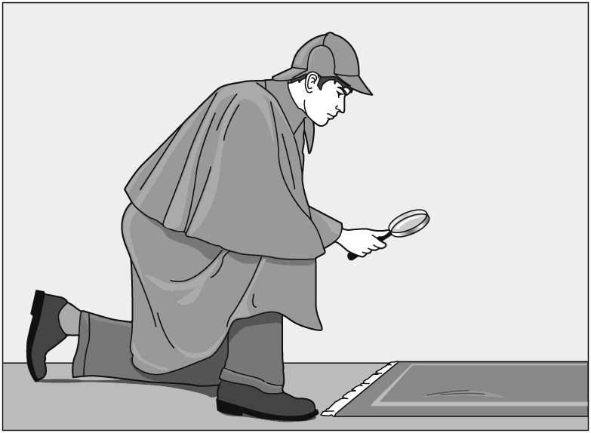

How is the person shown in this illustration acting like a scientist?

|  |  |
| --- | --- |
| A. | The person is working hard. |
| B. | The person is trying to solve a problem. |
| C. | The person is thinking about what to do next. |
| D. | The person is using a tool to help him make observations. |

____ 2. Many people need scientific knowledge for their careers. The following image shows an example.

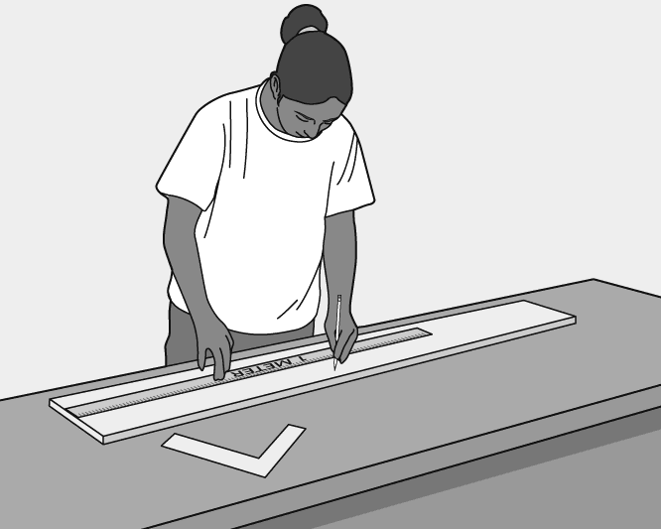

How is this person using scientific knowledge?

|  |  |
| --- | --- |
| A. | by planning ahead |
| B. | by using the proper tools |
| C. | by taking the time to avoid mistakes |
| D. | by using the metric system when measuring |

____ 3. In 2008, Dr. Lydia Villa-Komaroff was named as the National Hispanic Scientist of the Year. In addition to her many contributions to society, she was a member of a research team that first showed that bacterial cells can be made to produce insulin. This discovery helps people, with diabetes, who take insulin to control their blood-sugar levels. In what area did Dr. Villa-Komaroff’s work have an impact?

|  |  |
| --- | --- |
| A. | medical treatments |
| B. | new technologies |
| C. | disease prevention |
| D. | conservation efforts |

____ 4. In 2008, Evan B. Forde received a congressional commendation as “one of the nation’s leading African-American scientists and explorers.” He received the award in Jacksonville, Florida, where he works to help increase students’ interest in mathematics, oceanography, and earth science. In what area has Forde’s work had an impact on society?

|  |  |
| --- | --- |
| A. | education |
| B. | astronomy |
| C. | engineering |
| D. | energy resources |

____ 5. Scientific thought and investigation have had a tremendous impact on society. Which of the following scientific discoveries would have the **greatest** impact on society?

|  |  |
| --- | --- |
| A. | discovery of a gold deposit |
| B. | discovery of a new species of animal |
| C. | discovery of a new star in the universe |
| D. | discovery of a way to prevent a disease |

____ 6. Alexander Fleming was a Scottish scientist who discovered the antibiotic penicillin in 1928. In what area did Fleming’s discovery have an impact?

|  |  |
| --- | --- |
| A. | astronomy |
| B. | engineering |
| C. | treatment of diseases |
| D. | conservation practices |

____ 7. Science affects our lives in different ways. What is one way that science has directly affected our health?

|  |  |
| --- | --- |
| A. | discovery of planets |
| B. | vaccine development |
| C. | manufacture of efficient fuels |
| D. | discovery of the structure of the atom |

____ 8. In which of the following is a mechanic acting most like a scientist?

|  |  |
| --- | --- |
| A. | A mechanic eats a turkey sandwich and soup for lunch. |
| B. | A mechanic decides which type of oil would be best for a car. |
| C. | A mechanic uses robotic arms to lift a car in order to work underneath it. |
| D. | A mechanic makes an educated guess about why a car is not working, and then tests the guess. |

____ 9. Many people need scientific knowledge for their careers. The following image shows an example.



How is this person using scientific knowledge?

|  |  |
| --- | --- |
| A. | by planning ahead |
| B. | by developing a hypothesis |
| C. | by taking accurate measurements |
| D. | by using a sturdy table to measure on |

____ 10. What is one way that science has directly affected our ease of travel?

|  |  |
| --- | --- |
| A. | discovery of planets |
| B. | vaccine development |
| C. | development of the airplane |
| D. | discovery of the structure of the atom |

____ 11. Florida A&M University has an Environmental Sciences Institute. In which area would research at this institute **most** **likely** have an impact?

|  |  |
| --- | --- |
| A. | weather prediction |
| B. | new technology products |
| C. | development of new medicines |
| D. | conservation of natural resources |

____ 12. The graph shows the number of a school’s male and female athletes.

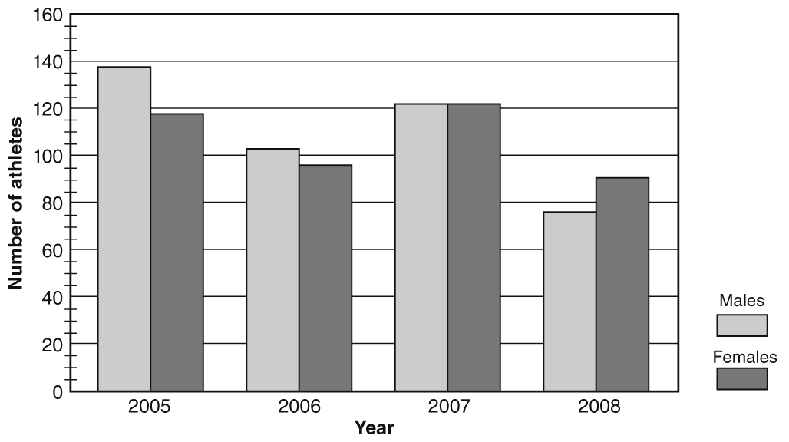

How can the data help the principal increase student participation in athletics?

|  |  |
| --- | --- |
| A. | She can identify from the data why students like participating in sports. |
| B. | She can see why there is a decrease in participation between 2005 and 2006. |
| C. | She can tell why there were equal numbers of male and female athletes in 2007. |
| D. | Participation data from the previous year can help her set goals for next year. |

**Short Answer**

1. Explain how the work of scientists benefits our society as a whole.

**Science and Society: PSSA Prep**

**Answer Section**

**MULTIPLE CHOICE**

1. ANS: D

A is incorrect because people in all professions and fields work hard.

B is incorrect because people in all professions and fields solve problems as part of their work.

C is incorrect because nothing in the illustration suggests that the person is thinking about the next step.

D is correct because scientists use tools to help them make observations.

PTS: 1

DIF: Cognitive Complexity: Moderate | Student Level: Average | Depth of Knowledge 2: Basic Application of Skill | Bloom's Traditional: Comprehension | Bloom's Revised: Understanding

REF: 7a44b590-09ec-11e0-a95d-001e33aa91d2 OBJ: G6_NC_67270_ScienceAndSociety

TOP: Diversity of Scientists: Some people, while not considered 'scientists,' still use science in their work.

KEY: scientist MSC: Uses visual element | Nature of Science | STEM | moduleK_Module Review

2. ANS: D

A is incorrect because although planning ahead is a good practice in any career, it does not require scientific knowledge.

B is incorrect because everyone must be sure to use the proper tools, a process that does not require any scientific knowledge.

C is incorrect because taking one’s time may avoid mistakes, but it does not require scientific knowledge.

D is correct because all scientists use the metric system when making measurements.

PTS: 1

DIF: Cognitive Complexity: Moderate | Student Level: Average | Depth of Knowledge 2: Basic Application of Skill | Bloom's Traditional: Comprehension | Bloom's Revised: Understanding

REF: 7a7e6330-09ec-11e0-a95d-001e33aa91d2 OBJ: G6_NC_67270_ScienceAndSociety

TOP: Diversity of Scientists: Some people, while not considered 'scientists,' still use science in their work.

KEY: scientist MSC: Uses visual element | Nature of Science | STEM | moduleK_u1 Unit Test B

3. ANS: A

A is correct because the use of insulin treats diabetes, which is a medical problem.

B is incorrect because no information is given that a new technology was developed.

C is incorrect because insulin is used to treat, not prevent, a disease.

D is incorrect because the production of insulin by bacteria was an advance in medicine, not in environmental science.

PTS: 1

DIF: Cognitive Complexity: Low | Student Level: Basic | Depth of Knowledge 1: Recall | Bloom's Traditional: Comprehension | Bloom's Revised: Understanding

REF: 7ab578c0-09ec-11e0-a95d-001e33aa91d2 OBJ: G6_NC_67270_ScienceAndSociety

TOP: Impact of Science on Society: Identify scientists with varied talents, interests, and goals who have made important contributions to science and society throughout history.

KEY: medicine | scientist | society MSC: Nature of Science | STEM | moduleK_u1_Lesson4 Quiz

4. ANS: A

A is correct because Forde works with students in their classrooms to stimulate their interest in math and science.

B is incorrect because Forde works as a role model in schools, not as an astronomer.

C is incorrect because the passage mentions only mathematics, oceanography, and earth science.

D is incorrect because no information is provided to suggest that Forde is involved in conserving energy resources or developing new ones.

PTS: 1

DIF: Cognitive Complexity: Low | Student Level: Basic | Depth of Knowledge 1: Recall | Bloom's Traditional: Comprehension | Bloom's Revised: Understanding

REF: 7a4810f0-09ec-11e0-a95d-001e33aa91d2 OBJ: G6_NC_67270_ScienceAndSociety

TOP: Impact of Science on Society: Identify scientists with varied talents, interests, and goals who have made important contributions to science and society throughout history.

KEY: scientist | society MSC: Nature of Science | STEM | moduleK_Module Review

5. ANS: D

A is incorrect because the gold may be valuable, but it will benefit only a small group of people.

B is incorrect because the discovery of a new species may help explain some point about evolution, but it will not have an impact on society as a whole.

C is incorrect because society will not benefit from the discovery of a new star.

D is correct because this discovery may save many lives.

PTS: 1

DIF: Cognitive Complexity: Low | Student Level: Basic | Depth of Knowledge 2: Basic Application of Skill | Bloom's Traditional: Comprehension | Bloom's Revised: Understanding

REF: 7ab837e0-09ec-11e0-a95d-001e33aa91d2 OBJ: G6_NC_67270_ScienceAndSociety

TOP: Impact of Science on Society: Describe how scientific thought and investigation have had a tremendous impact on society throughout history. KEY: scientist | society

MSC: Nature of Science | STEM | moduleK_u1_Lesson4 Quiz

6. ANS: C

A is incorrect because Fleming’s contribution was in life science.

B is incorrect because Fleming’s discovery of penicillin was the result of his scientific research, not engineering work.

C is correct because penicillin has been used to save many lives from bacterial infections.

D is incorrect because Fleming’s discovery of penicillin did not have any direct impact on conserving natural resources.

PTS: 1

DIF: Cognitive Complexity: Low | Student Level: Basic | Depth of Knowledge 1: Recall | Bloom's Traditional: Comprehension | Bloom's Revised: Understanding

REF: 7abb6c30-09ec-11e0-a95d-001e33aa91d2 OBJ: G6_NC_67270_ScienceAndSociety

TOP: Impact of Science on Society: Identify scientists with varied talents, interests, and goals who have made important contributions to science and society throughout history.

KEY: scientist | society MSC: Nature of Science | STEM | moduleK_u1_Lesson4 Quiz

7. ANS: B

A is incorrect because the discovery of planets does not directly affect our health.

B is correct because vaccines prevent people from getting viral diseases.

C is incorrect because efficient fuels do not directly affect our health.

D is incorrect because uncovering the structure of the atom does not directly affect our health.

PTS: 1

DIF: Cognitive Complexity: Low | Student Level: Average | Depth of Knowledge 2: Basic Application of Skill | Bloom's Traditional: Comprehension | Bloom's Revised: Understanding

REF: 7a6b7770-09ec-11e0-a95d-001e33aa91d2 OBJ: G6_NC_67270_ScienceAndSociety

TOP: Impact of Science on Society: Describe how scientific thought and investigation have had a tremendous impact on society throughout history. KEY: scientist | society

MSC: Nature of Science | STEM | moduleK_u1 Unit Test A

8. ANS: D

A is incorrect because eating lunch is not an example of the mechanic acting like a scientist.

B is incorrect because choosing oil for a car is not the mechanic acting like a scientist.

C is incorrect because using a robotic arm to hoist a car is not an example of the mechanic acting like a scientist.

D is correct because forming a hypothesis and testing the hypothesis is the best choice for how a mechanic acts like a scientist.

PTS: 1

DIF: Bloom's Traditional: Analysis | Bloom's Revised: Analyzing | Cognitive Complexity: Moderate | Depth of Knowledge 3: Strategic Thinking | Student Level: Average

REF: 8978fb90-fda6-11df-8e11-001e33aa91d2 OBJ: G6_NC_67270_ScienceAndSociety

TOP: Diversity of Scientists: Some people, while not considered 'scientists,' still use science in their work.

KEY: scientist MSC: Nature of Science | STEM | moduleK_u1_Lesson4 Quiz

9. ANS: C

A is incorrect because although planning ahead is a good practice in any career, it does not require scientific knowledge.

B is incorrect because this picture does not indicate that the person is making a hypothesis.

C is correct because all scientists use SI tools to take accurate measurements.

D is incorrect because using a sturdy table is not an example of using scientific knowledge.

PTS: 1

DIF: Bloom's Traditional: Comprehension | Bloom's Revised: Understanding | Cognitive Complexity: Moderate | Depth of Knowledge 2: Basic Application of Skill | Student Level: Basic

REF: 8b5ab3e0-fda6-11df-8e11-001e33aa91d2 OBJ: G6_NC_67270_ScienceAndSociety

TOP: Diversity of Scientists: Some people, while not considered 'scientists,' still use science in their work.

KEY: scientist MSC: Uses visual element | Nature of Science | STEM | moduleK_u1 Unit Test A

10. ANS: C

A is incorrect because the discovery of planets does not directly affect our ease of transportation. .

B is incorrect because transportation has not been eased by vaccines.

C is correct because the development of the airplane has directly affected the ease of transportation.

D is incorrect because uncovering the structure of the atom does not directly affect our ease of transportation.

PTS: 1

DIF: Bloom's Traditional: Comprehension | Bloom's Revised: Understanding | Cognitive Complexity: Low | Depth of Knowledge 2: Basic Application of Skill | Student Level: Basic

REF: 89c93e70-fda6-11df-8e11-001e33aa91d2 OBJ: G6_NC_67270_ScienceAndSociety

TOP: Impact of Science on Society: Describe how scientific thought and investigation have had a tremendous impact on society throughout history. KEY: scientist | society

MSC: Nature of Science | STEM | moduleK_u1 Unit Test B

11. ANS: D

A is incorrect because weather prediction is part of meteorology, not environmental science.

B is incorrect because environmental sciences do not focus on technology.

C is incorrect because environmental sciences do not focus on development of new medicines.

D is correct because conservation and protection of natural resources are of interest to environmental scientists.

PTS: 1

DIF: Bloom's Traditional: Comprehension | Bloom's Revised: Understanding | Cognitive Complexity: Low | Depth of Knowledge 2: Basic Application of Skill | Student Level: Basic

REF: 7a265820-09ec-11e0-a95d-001e33aa91d2 OBJ: G6_NC_67270_ScienceAndSociety

TOP: Impact of Science on Society: Describe how scientific thought and investigation have had a tremendous impact on society throughout history. KEY: scientist | society

MSC: Nature of Science | STEM | moduleK_u1 Pretest

12. ANS: D

A is incorrect because the data does not give reasons for participation, just numbers of students who participated.

B is incorrect because the data shows a decrease, but not the reason for the decrease.

C is incorrect because the reason for the equal number of participants is not evident on the graph.

D is correct because the graph gives her data about past participation numbers.

PTS: 1

DIF: Bloom's Traditional: Evaluation | Bloom's Revised: Evaluating | Cognitive Complexity: High | Depth of Knowledge 3: Strategic Thinking | Student Level: Advanced OBJ: G6_NC_67270_ScienceAndSociety

TOP: Diversity of Scientists: Some people, while not considered 'scientists,' still use science in their work.

KEY: science in everyday life | role of science in society | identify questions that can be answered through scientific exploration | interpreting visual elements such as tables, graphs, and diagrams | science as a human endeavor | science and society

MSC: moduleK_u1 Unit Review | Nature of Science | Uses visual element

**SHORT ANSWER**

1. ANS:

Answers may vary. Answers should include some of the following points:

•    that scientists work in many fields and thus can influence change in many different parts of society, any person who asks questions and looks for answers can be called a scientist (some scientists work in life science, earth science, physical science)

•    that scientists themselves come from many different backgrounds

•    that people in all walks of life use scientific principles to do their work in society

•    that scientific research has led to many life-saving discoveries, such as medicines, weather prediction, safer transport, and disease prevention, our ability to conserve and protect our resources

•    that new technology has improved human lives and changed the way humans think about the world

PTS: 2

DIF: Bloom's Traditional: Synthesis | Bloom's Revised: Analyzing | Cognitive Complexity: High | Depth of Knowledge 3: Strategic Thinking | Student Level: Advanced

OBJ: G8_NC_97990_WhatIsScience | G6_NC_67270_ScienceAndSociety

TOP: Impact of Science on Society: Describe how scientific thought and investigation have had a tremendous impact on society throughout history. | Impact of Science on Society: Identify scientists with varied talents, interests, and goals who have made important contributions to science and society throughout history. | Diversity of Scientists: Explain that scientists come from all kinds of backgrounds and possess varied talents, interests, and goals. | Diversity of Scientists: Some people, while not considered 'scientists,' still use science in their work.

KEY: science and society | nature of science | technology | traits of scientists | science as a career | finding solutions to problems | inventions and innovations | technology and society | using tools and technology | technology as a human endeavor | design process

**Representing Data: PSSA Prep**

**Multiple Choice**

*Identify the choice that best completes the statement or answers the question.*

____ 1. A city council decides that in the upcoming year, 15% of its budget will go to the police department, 10% of its budget will go to the fire department, 30% of its budget will go toward community development, 20% of its budget will go toward public works, and 25% of its budget will go toward various government operations. Which of the following graphs would most effectively represent this data?

|  |  |
| --- | --- |
| A. | line graph |
| B. | scatter plot |
| C. | circle graph |
| D. | box-and-whisker plot |

____ 2. Which of the following is a limitation of using a model to study something?

|  |  |
| --- | --- |
| A. | A model cannot represent a thing exactly. |
| B. | A model cannot help study things that are dangerous. |
| C. | A model cannot reproduce things that are too far away. |
| D. | A model cannot show things that are too small or too large. |

____ 3. Below is an example of a model.

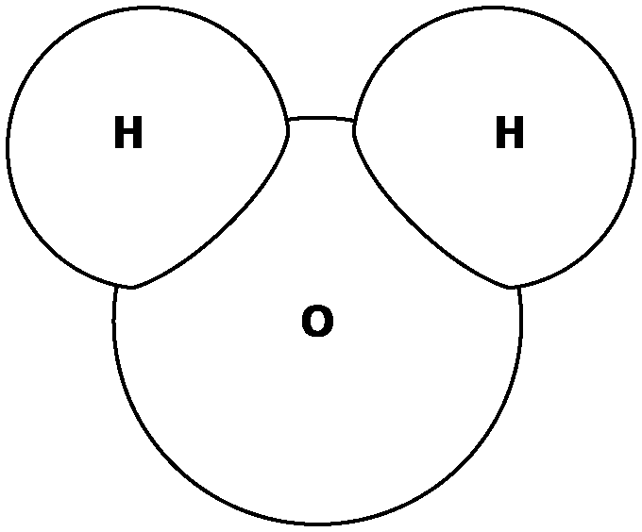

What would this model be used to study?

|  |  |
| --- | --- |
| A. | an atom |
| B. | a neutron |
| C. | a molecule |
| D. | a DNA strand |

____ 4. Scientists are conducting an experiment in which they give people different amounts of Vitamin C to determine whether Vitamin C intake has an effect on how often a person gets sick. What is the dependent variable in this experiment?

|  |  |
| --- | --- |
| A. | the amount of vitamin C |
| B. | the type of illness a person gets |
| C. | the brand of vitamin C being used |
| D. | the number of illnesses a person gets |

____ 5. Scientists are conducting an experiment in which they give people different amounts of Vitamin C to determine whether Vitamin C intake has an effect on how often a person gets sick. What is the independent variable in this experiment?

|  |  |
| --- | --- |
| A. | the amount of vitamin C |
| B. | how often a person gets sick |
| C. | the type of illness a person gets |
| D. | the brand of vitamin C being used |

____ 6. A biologist uses a model of a cell to teach a class about the different parts that make up a cell. What is the most likely reason the biologist chose a model instead of an actual cell to teach the class?

|  |  |
| --- | --- |
| A. | A real cell is too large to study. |
| B. | A real cell is too small to study. |
| C. | A real cell is too far away to study. |
| D. | A real cell is too dangerous to study. |

____ 7. A scientist is using a model to predict when a volcano might erupt again. What kind of model is the scientist most likely to use?

|  |  |
| --- | --- |
| A. | scale model |
| B. | computer model |
| C. | physical model |
| D. | diagram |

____ 8. Scientists often use visual or mathematical representations to investigate items that are very large, very small, or otherwise difficult to study. What are these visual or mathematical representations called?

|  |  |
| --- | --- |
| A. | experiments |
| B. | hypotheses |
| C. | models |
| D. | observations |

____ 9. Look at the figure below.

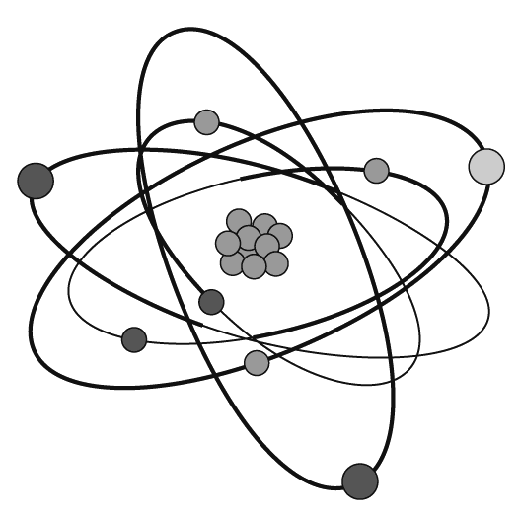

What is this an example of?

|  |  |
| --- | --- |
| A. | a model |
| B. | a hypothesis |
| C. | an experiment |
| D. | an observation |

____ 10. Identifying the independent and dependent variables in an experiment will help you better interpret and convey results. What is the difference between the independent and dependent variables in an experiment?

|  |  |
| --- | --- |
| A. | The independent variable is always a number, and the dependent variable is never a number. |
| B. | The independent variable is what you control, and the dependent variable is what changes as a result. |
| C. | The dependent variable is what the investigator controls, and the independent variable is what happens as a result of this. |
| D. | The dependent variable is typically found in the first column of a table, and the independent variable is typically found in the second column. |

____ 11. The school physician performed an experiment to investigate the effects of aerobic exercise on high school freshmen. He examined 25 student volunteers and found them to be in good health. He then had the students perform aerobic exercises, such as jogging, swimming, and bicycling. The doctor recorded the students’ pulse rates before each activity, during each activity, and after each activity. Which was the dependent variable in this experiment?

|  |  |
| --- | --- |
| A. | the physician |
| B. | the exercises |
| C. | the volunteers |
| D. | the pulse rates |

____ 12. Wilson measured the air temperature at a particular location every three hours for one day. He organized his findings using a bar graph.

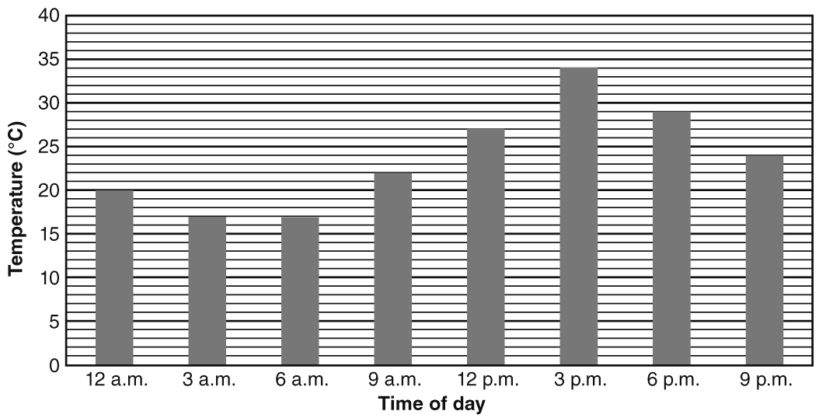

At what time was the temperature the **hottest**?

|  |  |
| --- | --- |
| A. | 12:00 p.m. (noon) |
| B. | 3:00 p.m. |
| C. | 6:00 p.m. |
| D. | 9:00 p.m. |

____ 13. A graph can help scientists display and convey data. What part of a line graph shows trends?

|  |  |
| --- | --- |
| A. | title |
| B. | legend |
| C. | *x*- and *y*-axis labels |
| D. | line of best fit |

____ 14. The students in Mrs. Dhaibar’s science class take a test. She uses a circle graph to show the results of the test. Each wedge shows a grade range. For example, one wedge shows how many students earned an A.

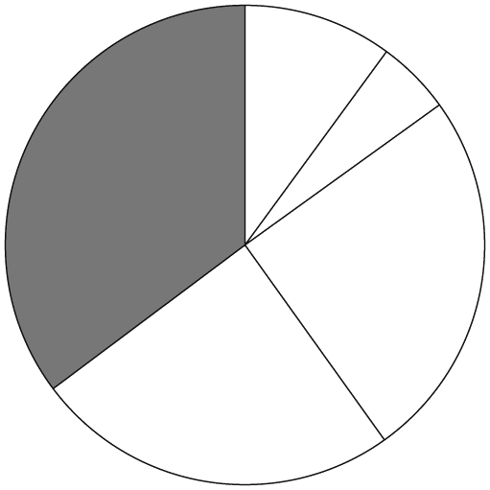

Which percentage of students got the grade shown in the shaded wedge?

|  |  |
| --- | --- |
| A. | 15% |
| B. | 25% |
| C. | 35% |
| D. | 50% |

____ 15. For which of the following situations would a circle graph be most effective?

|  |  |
| --- | --- |
| A. | a meteorologist wants to represent the high and low temperature recorded each day during the past month |
| B. | a teacher wants to represent the number of questions that each of his students answered correctly on their final exam |
| C. | a city council wants to represent the percentage of its budget received by each city department during the past year |
| D. | a scientist wants to represent the height reached by each pea plant exposed to different amounts of carbon dioxide in an experiment |

**Short Answer**

1. Explain what a model is. What disadvantage could there be in using a model to represent data?

**Other**

1. Visual or mathematical representations used to develop scientific explanations are called ____________________.

**Representing Data: PSSA Prep**

**Answer Section**

**MULTIPLE CHOICE**

1. ANS: C

A is incorrect because a line graph is not the most effective graph for representing percentages.

B is incorrect because a scatter plot is not the most effective graph for representing percentages.

C is correct because a circle graph is the most effective graph for representing percentages.

D is incorrect because a box-and-whisker plot is not the most effective graph for representing percentages.

PTS: 1

DIF: Bloom's Traditional: Evaluation | Bloom's Revised: Evaluating | Cognitive Complexity: High | Depth of Knowledge 3: Strategic Thinking | Student Level: Advanced

REF: 8a2f5340-fda6-11df-8e11-001e33aa91d2 OBJ: G6_NC_97020_RepresentingData

TOP: Graphs: Construct graphs. KEY: graph | construct

MSC: Nature of Science | STEM | moduleK_u2 Unit Test A

2. ANS: A

A is correct because a model is not able to reproduce everything about the phenomenon it represents.

B is incorrect because a model can be used to study things that are too dangerous to study in person, such as an erupting volcano.

C is incorrect because a model can be use to reproduce something that is too far away to see in person, such as the solar system.

D is incorrect because a model can be used to show things that are too large or small to see without assistive technology, such as a molecule.

PTS: 1

DIF: Bloom's Traditional: Comprehension | Bloom's Revised: Understanding | Cognitive Complexity: Low | Depth of Knowledge 1: Recall | Student Level: Basic

REF: 8a356dc0-fda6-11df-8e11-001e33aa91d2 OBJ: G6_NC_97020_RepresentingData

TOP: Models: Identify limitations of models. KEY: model | limitation

MSC: Nature of Science | STEM | moduleK_u2_Lesson1 Quiz

3. ANS: C

A is incorrect because this is an example of a molecule consisting of 3 atoms.

B is incorrect because this is not an example of a neutron.

C is correct because this is an example of a molecule of water.

D is incorrect because this is not a DNA strand.

PTS: 1

DIF: Bloom's Traditional: Analysis | Bloom's Revised: Analyzing | Cognitive Complexity: Moderate | Depth of Knowledge 3: Strategic Thinking | Student Level: Average

REF: 8a38a210-fda6-11df-8e11-001e33aa91d2 OBJ: G6_NC_97020_RepresentingData

TOP: Models: Select appropriate models to relate scientific data.

KEY: model MSC: Uses visual element | Nature of Science | STEM | moduleK_u2 Pretest

4. ANS: D

A is incorrect because the amount of vitamin C is the independent variable, which is being manipulated.

B is incorrect because the scientists are not testing the type of illness.

C is incorrect because the scientists are not determining what brand of vitamin C works best.

D is correct because the number of illnesses may be dependent on the amount of vitamin C received, which makes it the dependent variable.

PTS: 1

DIF: Bloom's Traditional: Analysis | Bloom's Revised: Analyzing | Cognitive Complexity: Moderate | Depth of Knowledge 3: Strategic Thinking | Student Level: Average

REF: 8a3bfd70-fda6-11df-8e11-001e33aa91d2 OBJ: G6_NC_97020_RepresentingData

TOP: Tables: Define dependent variable. KEY: independent variable

MSC: Nature of Science | STEM | moduleK_u2 Unit Test A

5. ANS: A

A is correct because the amount of vitamin C is the independent variable, which is being manipulated.

B is incorrect because the scientists are not determining what brand of vitamin C works best.

C is incorrect because the scientists are not testing the type of illness.

D is incorrect because the number of illnesses may be dependent on the amount of vitamin C received.

PTS: 1

DIF: Bloom's Traditional: Analysis | Bloom's Revised: Analyzing | Cognitive Complexity: Moderate | Depth of Knowledge 3: Strategic Thinking | Student Level: Average

REF: 8b611c80-fda6-11df-8e11-001e33aa91d2 OBJ: G6_NC_97020_RepresentingData

TOP: Tables: Define independent variable. KEY: independent variable

MSC: Nature of Science | STEM | moduleK_u2 Unit Test B

6. ANS: B

A is incorrect because a cell is microscopic.

B is correct because a real cell is microscopic, and a model lets the biologist teach the class without needing microscopes and other equipment.

C is incorrect because a real cell is not necessarily too far away to study.

D is incorrect because a real cell is not necessarily too dangerous to study.

PTS: 1

DIF: Bloom's Traditional: Analysis | Bloom's Revised: Analyzing | Cognitive Complexity: Moderate | Depth of Knowledge 3: Strategic Thinking | Student Level: Average

REF: 8a45c170-fda6-11df-8e11-001e33aa91d2 OBJ: G6_NC_97020_RepresentingData

TOP: Models: Identify advantages of models. KEY: model | advantage

MSC: Nature of Science | STEM | moduleK_u2 Unit Test A

7. ANS: B

A is incorrect because a scale model is a physical model that helps a scientist study the physical features of a volcano.

B is correct because the scientist wants to make a prediction about a future event. Many different variables affect when a volcano will erupt, and a computer model would most effectively work with these variables to help the scientist make a reasonable prediction.

C is incorrect because a physical model helps a scientist study the physical features of a volcano.

D is incorrect because a diagram is a two-dimensional physical model that helps a scientist study the physical features of a volcano.

PTS: 1

DIF: Bloom's Traditional: Analysis | Bloom's Revised: Analyzing | Cognitive Complexity: Moderate | Depth of Knowledge 3: Strategic Thinking | Student Level: Average

REF: 8bbb7180-fda6-11df-8e11-001e33aa91d2 OBJ: G6_NC_97020_RepresentingData

TOP: Models: Identify advantages of models. KEY: model | advantage

MSC: Nature of Science | STEM | moduleK_u2 Unit Test B

8. ANS: C

A is incorrect because experiments are investigational processes with various steps that often require the manipulation of materials and equipment.

B is incorrect because hypotheses are testable explanations of observed phenomena.

C is correct because models are visual or mathematical representations that can be used in many different ways.

D is incorrect because observations are data that scientists collect using their senses and/or tools.

PTS: 1

DIF: Cognitive Complexity: Low | Student Level: Basic | Depth of Knowledge 1: Recall | Bloom's Traditional: Knowledge | Bloom's Revised: Remembering

REF: 7ae98110-09ec-11e0-a95d-001e33aa91d2 OBJ: G6_NC_97020_RepresentingData

TOP: Models: Define model. KEY: scientific model | representation

MSC: moduleK_u2_Lesson1 Quiz | Nature of Science | STEM

9. ANS: A

A is correct because the figure is a visual representation of an atom and therefore is a model.

B is incorrect because a hypothesis is an attempt to explain observed phenomena.

C is incorrect because an experiment consists of various steps designed to answer a question.

D is incorrect because an observation is something a scientist takes note of to collect information.

PTS: 1

DIF: Cognitive Complexity: Low | Student Level: Basic | Depth of Knowledge 1: Recall | Bloom's Traditional: Comprehension | Bloom's Revised: Understanding

REF: 7ac668b0-09ec-11e0-a95d-001e33aa91d2 OBJ: G6_NC_97020_RepresentingData

TOP: Models: Define model. | Models: Select appropriate models to relate scientific data. | Models: Use models to represent aspects of the natural world.

KEY: atomic model | atom | scientific model

MSC: Uses visual element | Nature of Science | STEM | moduleK_Module Review

10. ANS: B

A is incorrect because the independent and dependent variables may or may not be numbers.

B is correct because the independent variable is what the investigator controls, and the dependent variable changes as a result of this manipulation.

C is incorrect because the independent variable is what you control, and the dependent variable is what happens as a result of this.

D is incorrect because the independent variable is typically found in the first column of a table, and the dependent variable is typically found in the second column.

PTS: 1

DIF: Cognitive Complexity: Low | Student Level: Basic | Depth of Knowledge 1: Recall | Bloom's Traditional: Comprehension | Bloom's Revised: Understanding

REF: 7aee14f0-09ec-11e0-a95d-001e33aa91d2 OBJ: G6_NC_97020_RepresentingData

TOP: Tables: Define independent variable. | Tables: Define dependent variable.

KEY: independent variable | dependent variable

MSC: moduleK_u2_Lesson1 Quiz | Nature of Science | STEM

11. ANS: D

A is incorrect because the physician was the investigator.

B is incorrect because the exercises were the independent variable in this experiment.

C is incorrect because the student volunteers were the subjects of this experiment.

D is correct because the pulse rates depended on the exercises that the students performed.

PTS: 1

DIF: Cognitive Complexity: Moderate | Student Level: Average | Depth of Knowledge 2: Basic Application of Skill | Bloom's Traditional: Comprehension | Bloom's Revised: Understanding

REF: 7ad20170-09ec-11e0-a95d-001e33aa91d2 OBJ: G6_NC_97020_RepresentingData

TOP: Tables: Define independent variable. | Tables: Define dependent variable.

KEY: independent variable | dependent variable

MSC: moduleK_u2 Pretest | STEM | Nature of Science

12. ANS: B

A is incorrect because the hottest temperature (34 °C) took place at 3:00 p.m., not 12:00 p.m. (noon).

B is correct because the hottest temperature (34 °C) took place at 3:00 p.m.

C is incorrect because the hottest temperature (34 °C) took place at 3:00 p.m., not 6:00 p.m.

D is incorrect because the hottest temperature (34 °C) took place at 3:00 p.m., not 9:00 p.m.

PTS: 1

DIF: Cognitive Complexity: Low | Student Level: Basic | Depth of Knowledge 1: Recall | Bloom's Traditional: Comprehension | Bloom's Revised: Understanding

REF: 7ad7cdd0-09ec-11e0-a95d-001e33aa91d2 OBJ: G6_NC_97020_RepresentingData

TOP: Graphs: Interpret data in graphs. KEY: graph | data | interpret

MSC: Uses visual element | Nature of Science | STEM | moduleK_u2 Unit Test A

13. ANS: D

A is incorrect because the title of a line graph indicates what the graph represents.

B is incorrect because the legend of a line graph indicates what each type of line represents.

C is incorrect because the axes of a line graph show the independent and dependent variables.

D is correct because trends are shown on line graphs by lines of best fit that are based on data points.

PTS: 1

DIF: Cognitive Complexity: Low | Student Level: Basic | Depth of Knowledge 1: Recall | Bloom's Traditional: Comprehension | Bloom's Revised: Understanding

REF: 7af58f00-09ec-11e0-a95d-001e33aa91d2 OBJ: G6_NC_97020_RepresentingData

TOP: Graphs: Interpret data in graphs. KEY: graph | data | interpret

MSC: moduleK_u2_Lesson1 Quiz | Nature of Science | STEM

14. ANS: C

A is incorrect because the shaded wedge is larger than a quarter of the pie, so it is larger than 15%.

B is incorrect because the shaded wedge is larger than a quarter of the pie, so it is larger than 25%.

C is correct because the shaded wedge is larger than a quarter of the pie and smaller than half the pie. The answer choice that corresponds to this range is 35%.

D is incorrect because the shaded wedge is smaller than half of the pie, so it is less than 50%.

PTS: 1

DIF: Bloom's Traditional: Evaluation | Bloom's Revised: Evaluating | Cognitive Complexity: High | Depth of Knowledge 3: Strategic Thinking | Student Level: Advanced

REF: 8b95e820-fda6-11df-8e11-001e33aa91d2 OBJ: G6_NC_97020_RepresentingData

TOP: Tables: Interpret data in tables. | Graphs: Interpret data in graphs.

KEY: graph | data | interpret | circle graph

MSC: Uses visual element | Nature of Science | STEM | moduleK_u2 Unit Test B

15. ANS: C

A is incorrect because a line graph would be the most effective way to represent changes in temperature throughout a month.

B is incorrect because a scatter plot would be the most effective way to represent the number of questions answered correctly by each student in a class.

C is correct because a circle graph is the most effective graph for representing pieces of a whole, such as the percentages of a total budget.

D is incorrect because a scatter plot would be the most effective way to represent the different heights reached by pea plants in an experiment.

PTS: 1

DIF: Bloom's Traditional: Evaluation | Bloom's Revised: Evaluating | Cognitive Complexity: Moderate | Depth of Knowledge 3: Strategic Thinking | Student Level: Average

REF: 7ac3d0a0-09ec-11e0-a95d-001e33aa91d2 OBJ: G6_NC_97020_RepresentingData

TOP: Graphs: Construct graphs. KEY: graph | construct

MSC: Nature of Science | STEM | moduleK_u2 Unit Test B

**SHORT ANSWER**

1. ANS:

Sample answer:

•    A scientific model is either a visual or mathematical representation of a scientific explanation.

•    A disadvantage of using models might be that a certain model is not able to reproduce everything about the phenomenon it represents

PTS: 2

DIF: Bloom's Traditional: Synthesis | Bloom's Revised: Analyzing | Cognitive Complexity: Moderate | Depth of Knowledge 3: Strategic Thinking | Student Level: Average

OBJ: G6_NC_97200_RepresentingData

TOP: Models: Define model. | Models: Identify limitations of models.

KEY: model | data MSC: moduleK_u2 Unit Review | Nature of Science

**OTHER**

1. ANS:

Rationale: Models can be a pattern, a plan, or a representation that show a scientific explanation.

PTS: 2

DIF: Bloom's Traditional: Comprehension | Bloom's Revised: Understanding | Cognitive Complexity: Low | Depth of Knowledge 1: Recall | Student Level: Basic OBJ: G6_NC_97200_RepresentingData

TOP: Models: Define model. KEY: scientific model | mathematical representation

MSC: moduleK_u2 Unit Review | Nature of Science

**Scientific Tools and Measurement: PSSA Prep**

**Multiple Choice**

*Identify the choice that best completes the statement or answers the question.*

____ 1. You are making a measurement using meters and find that the number value is 10. What is the correct way to write this scientific measurement?

|  |  |
| --- | --- |
| A. | meters |
| B. | 10 |
| C. | 10 meters |
| D. | meters 10 |

____ 2. Why was the International System of Units (SI) developed?

|  |  |
| --- | --- |
| A. | It was developed to compete with the English Standard System of Units. |
| B. | It was developed to allow countries to follow their own systems of measurement. |
| C. | It was developed to help scientists keep their data, observations, and measurements secret from other scientists. |
| D. | It was developed to help scientists compare measurements made by different people in different locations using different tools. |

____ 3. The image below shows four measurements (small dots) and an actual value (larger center).

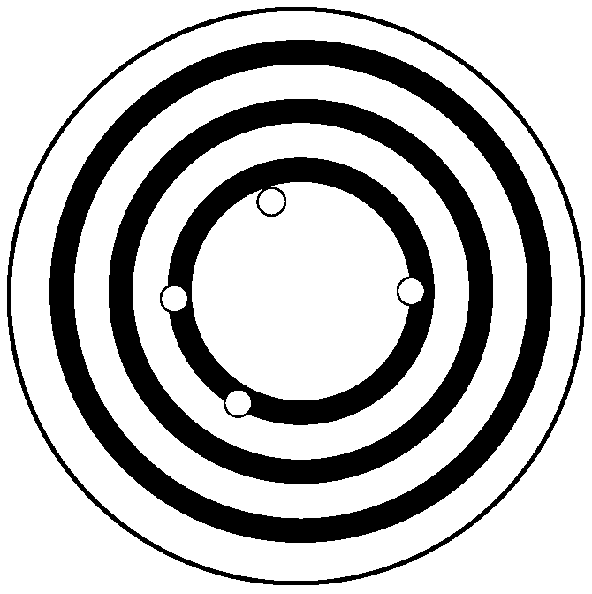

How can we describe these measurements in terms of accuracy and precision?

|  |  |
| --- | --- |
| A. | The measurements are accurate but not precise. |
| B. | The measurements are precise but not accurate. |
| C. | The measurements are both accurate and precise. |
| D. | The measurements are neither accurate nor precise. |

____ 4. Which of the following is the most likely reason why scientists use approximate measurements?

|  |  |
| --- | --- |
| A. | Scientists do not use approximate measurements as that would be unscientific. |
| B. | Scientists use approximate measurements to determine whether the data they collected is reasonable. |
| C. | Scientists use approximate measurements to record images of objects or environments in a brief interval of time. |
| D. | Scientists use approximate measurements to help take measurements that cannot be detected by the senses alone. |

____ 5. A scientist wants to track a hurricane and predict where it will go next. What is the best tool for the scientist to use?

|  |  |
| --- | --- |
| A. | a computer |
| B. | a hand lens |
| C. | an electron microscope |
| D. | a magnetic resonance image |

____ 6. In which of the following situations would an estimate be most appropriate to use?

|  |  |
| --- | --- |
| A. | determining which tool to use to obtain an estimate |
| B. | determining whether a projected budget is reasonable |
| C. | assessing whether students in a class fully understand a new concept |
| D. | determining which students in a class are going to pass and which are going to fail |

____ 7. Which measurement and SI unit are incorrectly matched?

|  |  |
| --- | --- |
| A. | length: feet |
| B. | time: second |
| C. | mass: kilogram |
| D. | temperature: Kelvin |

____ 8. What is the term for the way scientists use only a few numbers to represent a very large or very small number?

|  |  |
| --- | --- |
| A. | metric units |
| B. | measurements |
| C. | scientific notation |
| D. | customary system of units |

____ 9. A laboratory scientist wants to heat a liquid substance and then store it in several containers. What tools would the scientist most likely use?

|  |  |
| --- | --- |
| A. | hot plate and test tubes |
| B. | stopwatch and beakers |
| C. | thermometer and graduated cylinders |
| D. | Bunsen burner and triple beam balances |

____ 10. Below are the results of a chemistry lab experiment.

|  |  |
| --- | --- |
| **Trial #** | **Measurement (kg)** |
| 1 | 35 |
| 2 | 36 |
| 3 | 34 |
| 4 | 36 |
| 5 | 35 |

If the actual value were 35 kg, what can be said about the measurements?

|  |  |
| --- | --- |
| A. | The measurements are accurate and precise. |
| B. | The measurements are accurate but not precise. |
| C. | The measurements are precise but not accurate. |
| D. | The measurements are neither accurate nor precise. |

____ 11. Earth has a mass of 5.9736  1024 kilograms. What is this number in regular (not scientific) notation?

|  |  |
| --- | --- |
| A. | 59,736,000,000,000 |
| B. | 59,736,000,000,000,000,000 |
| C. | 5,973,600,000,000,000,000,000,000 |
| D. | 5,973,600,000,000,000,000,000,000,000 |

____ 12. Which of the following is not a correct match between a measurement and the tool used to make that measurement?

|  |  |
| --- | --- |
| A. | time: stopwatch |
| B. | length: meter stick |
| C. | mass: graduated cylinder |
| D. | temperature: thermometer |

____ 13. What scientific tool would best be used to study your cheek cells?

|  |  |
| --- | --- |
| A. | a hand lens |
| B. | an electron microscope |
| C. | an MRI (magnetic resonance imagery) |
| D. | a CAT scan (computerized axial tomography) |

____ 14. Below are the results of a chemistry lab experiment.

|  |  |
| --- | --- |
| **Trial #** | **Measurement (kg)** |
| 1 | 35 |
| 2 | 36 |
| 3 | 34 |
| 4 | 36 |
| 5 | 35 |

If the actual value was 42 kg, what can be said about the measurements?

|  |  |
| --- | --- |
| A. | The measurements are accurate and precise. |
| B. | The measurements are accurate but not precise. |
| C. | The measurements are precise but not accurate. |
| D. | The measurements are neither accurate nor precise. |

____ 15. Earth has a mass of 5,973,600,000,000,000,000,000,000 kilograms. How is this written in scientific notation?

|  |  |
| --- | --- |
| A. | 5.9736 ? 1024 kg |
| B. | 597.36 ? 1022 kg |
| C. | 59,736 ? 1025 kg |
| D. | 5,973,600,000,000,000,000,000,000 kg |

____ 16. How would a biologist best use a computer to predict the amount of rainforest that will be destroyed over the next decade?

|  |  |
| --- | --- |
| A. | run a simulation based on trends |
| B. | graph data from direct observations |
| C. | create a real-time animation |
| D. | represent indirect observations |

____ 17. Which is a tool that scientists would least likely use in a lab?

|  |  |
| --- | --- |
| A. | test tube |
| B. | hot plate |
| C. | electron microscope |
| D. | a yard stick |

____ 18. Below are the results of a chemistry lab experiment.

|  |  |
| --- | --- |
| **Trial #** | **Measurement (kg)** |
| 1 | 41 |
| 2 | 13 |
| 3 | 41 |
| 4 | 42 |
| 5 | 40 |

If the object measured actually has a mass of 42 kg, which of the following is true?

|  |  |
| --- | --- |
| A. | All of the measurements are accurate and precise. |
| B. | None of the measurements are accurate or precise. |
| C. | The results of Trial 2 were likely caused by experimental error. |
| D. | Only Trial 4 should be used because it produced the only correct measurement. |

**Short Answer**

1. Explain two ways that a computer can be used as a tool for scientific investigation.

___________________________________________________

___________________________________________________

___________________________________________________

___________________________________________________

**Other**

1. A ____________________ is a description of something that includes a number and a unit.

**Scientific Tools and Measurement: PSSA Prep**

**Answer Section**

**MULTIPLE CHOICE**

1. ANS: C

A is incorrect because writing meters does not tell us the number in the measurement.

B is incorrect because writing 10 does not tell us the unit in the measurement.

C is correct because the answer includes the number and the unit in the correct order.

D is incorrect because the measurement is not in order with the number first and the unit second.

PTS: 1

DIF: Bloom's Traditional: Comprehension | Bloom's Revised: Understanding | Cognitive Complexity: Low | Depth of Knowledge 1: Recall | Student Level: Basic

REF: 89266ec0-fda6-11df-8e11-001e33aa91d2

OBJ: G6_NC_87028_ScientificToolsAndMeasurements

TOP: Measurement; system: Explain how a measurement is used to describe something.

KEY: measurement MSC: Nature of Science | STEM | moduleK_u2_Lesson2 Quiz

2. ANS: D

A is incorrect because the SI was not developed to compete with any other measurement system.

B is incorrect because the SI enabled countries to use just one system.

C is incorrect because the SI was designed to allow scientists to share their scientific discoveries, not keep them secret.

D is correct because the SI was designed to allow scientists from everywhere to share data, observations, and measurements with other scientists.

PTS: 1

DIF: Bloom's Traditional: Comprehension | Bloom's Revised: Remembering | Cognitive Complexity: Low | Depth of Knowledge 1: Recall | Student Level: Basic

REF: 892954f0-fda6-11df-8e11-001e33aa91d2

OBJ: G6_NC_87028_ScientificToolsAndMeasurements

TOP: Measurement; system: Explain why the International System of Units was developed.

KEY: International System of Units | SI | measurement

MSC: Nature of Science | STEM | moduleK_u2_Lesson2 Quiz

3. ANS: A

A is correct because the measurements are close to the actual value (accurate), and they are far apart from one another (not precise).

B is incorrect because the measurements are close to the actual value (accurate), and they are far apart from one another (not precise).

C is incorrect because even though the measurements are close to the actual value (accurate), they are not near one another (precise).

D is incorrect because the measurements are close to the center (accurate), even though they are not close to one another (precise).

PTS: 1

DIF: Bloom's Traditional: Analysis | Bloom's Revised: Analyzing | Cognitive Complexity: Moderate | Depth of Knowledge 3: Strategic Thinking | Student Level: Average

REF: 892cd760-fda6-11df-8e11-001e33aa91d2

OBJ: G6_NC_87028_ScientificToolsAndMeasurements

TOP: Measurement; tools: Describe the precision and accuracy of a data set.

KEY: measurement | accuracy | precision

MSC: Uses visual element | Nature of Science | STEM | moduleK_u2_Lesson2 Quiz

4. ANS: B

A is incorrect because scientists do use approximate measurements (estimates).

B is correct because scientists use approximate measurements (estimates) to determine whether the data they collected is reasonable.

C is incorrect because scientists use digital cameras to accomplish the recording of objects or environments in a brief interval of time.

D is incorrect because various tools help scientists take measurements that cannot be detected by the senses alone.

PTS: 1

DIF: Bloom's Traditional: Knowledge | Bloom's Revised: Remembering | Cognitive Complexity: Low | Depth of Knowledge 1: Recall | Student Level: Basic

REF: 892fe4a0-fda6-11df-8e11-001e33aa91d2

OBJ: G6_NC_87028_ScientificToolsAndMeasurements

TOP: Measurement; tools: Explain why scientists may use estimates or approximate measurements.

KEY: estimate | approximate measurement

MSC: Nature of Science | STEM | moduleK_u2_Lesson2 Quiz

5. ANS: A

A is correct because a computer is the only tool listed that can store data, display trends, generate models, and run simulations. All of these are necessary to track a hurricane.

B is incorrect because a hand lens helps scientists magnify things.

C is incorrect because an electron microscope magnifies very small objects.

D is incorrect because an MRI would not be used to track a hurricane.

PTS: 1

DIF: Bloom's Traditional: Evaluation | Bloom's Revised: Evaluating | Cognitive Complexity: High | Depth of Knowledge 3: Strategic Thinking | Student Level: Advanced

REF: 89327cb0-fda6-11df-8e11-001e33aa91d2

OBJ: G6_NC_87028_ScientificToolsAndMeasurements

TOP: Tools; scientific: List examples of tools scientists may use in the lab and describe their purposes. | Tools; scientific: Describe how computers and technology can be used as tools for scientific investigations.

KEY: scientific tool | computer | data analysis

MSC: Nature of Science | STEM | moduleK_u2_Lesson2 Quiz

6. ANS: B

A is incorrect because deciding which tool to use to obtain a measurement requires an exact answer, not an estimate.

B is correct because the budget is simply a projection, so an estimate is appropriate to use.

C is incorrect because assessing whether students fully understand a concept requires an exact answer, not an estimate.

D is incorrect because determining whether students pass or fail a class requires an exact answer (grades), not an estimate.

PTS: 1

DIF: Bloom's Traditional: Evaluation | Bloom's Revised: Evaluating | Cognitive Complexity: High | Depth of Knowledge 3: Strategic Thinking | Student Level: Advanced

REF: 8bd959c0-fda6-11df-8e11-001e33aa91d2

OBJ: G6_NC_87028_ScientificToolsAndMeasurements

TOP: Measurement; tools: Explain why scientists may use estimates or approximate measurements.

KEY: tool | measurement | estimate MSC: Nature of Science | STEM

7. ANS: A

A is correct because if using SI, length is measured in meters, not feet.

B is incorrect because time is measured in seconds.

C is incorrect because mass is measured in kilograms.

D is incorrect because temperature is measured in Kelvin.

PTS: 1

DIF: Bloom's Traditional: Knowledge | Bloom's Revised: Remembering | Cognitive Complexity: Low | Depth of Knowledge 1: Recall | Student Level: Basic

REF: 8a67c860-fda6-11df-8e11-001e33aa91d2

OBJ: G6_NC_87028_ScientificToolsAndMeasurements

TOP: Measurement; tools: Identify units of length, mass, time, and temperature and the tools used to make those measurements. KEY: measurement | length | mass | temperature | time | SI

MSC: Nature of Science | STEM | moduleK_u2 Pretest

8. ANS: C

A is incorrect because scientific notation is the short way of representing very large or very small numbers. Metric units are based on the number 10.

B is incorrect because scientific notation is the short way of representing very large or very small numbers. A measurement is a numerical description and includes a unit.

C is correct because scientific notation is the short way of representing very large or very small numbers.

D is incorrect because scientific notation is the short way of representing very large or very small numbers.

PTS: 1

DIF: Bloom's Traditional: Knowledge | Bloom's Revised: Remembering | Cognitive Complexity: Low | Depth of Knowledge 1: Recall | Student Level: Basic

REF: 8a6b23c0-fda6-11df-8e11-001e33aa91d2

OBJ: G6_NC_87028_ScientificToolsAndMeasurements

TOP: Measurement; system: Express numbers in scientific notation where appropriate.

KEY: measurement | scientific notation MSC: Nature of Science | STEM | moduleK_u2 Pretest

9. ANS: A

A is correct because a hot plate and a test tube would be the best choices for heating a liquid.

B is incorrect because a stopwatch measures time.

C is incorrect because a thermometer measures temperature, it does not heat.

D is incorrect because although the Bunsen burner can heat a liquid, a triple beam balance is used to measure mass.

PTS: 1

DIF: Bloom's Traditional: Application | Bloom's Revised: Applying | Cognitive Complexity: Moderate | Depth of Knowledge 2: Basic Application of Skill | Student Level: Average

REF: 8a6e5810-fda6-11df-8e11-001e33aa91d2

OBJ: G6_NC_87028_ScientificToolsAndMeasurements

TOP: Tools; scientific: List examples of tools scientists may use in the lab and describe their purposes. | Measurement; tools: Identify units of length, mass, time, and temperature and the tools used to make those measurements. KEY: measurement | tool

MSC: Nature of Science | STEM | moduleK_u2 Pretest

10. ANS: A

A is correct because the measurements are both accurate (the values are close to the actual value) and precise (each value is close to all the other values measured).

B is incorrect because the measurements are both accurate (the values are close to the actual value) and precise (each value is close to all the other values measured).

C is incorrect because the measurements are both accurate (the values are close to the actual value) and precise (each value is close to all the other values measured).

D is incorrect because the measurements are both accurate (the values are close to the actual value) and precise (each value is close to all the other values measured).

PTS: 1

DIF: Bloom's Traditional: Evaluation | Bloom's Revised: Evaluating | Cognitive Complexity: High | Depth of Knowledge 3: Strategic Thinking | Student Level: Advanced

REF: 8b747d70-fda6-11df-8e11-001e33aa91d2

OBJ: G6_NC_87028_ScientificToolsAndMeasurements

TOP: Measurement; tools: Describe the precision and accuracy of a data set.

KEY: measurement | accuracy | precision

MSC: Uses visual element | Nature of Science | STEM | moduleK_u2 Unit Test A

11. ANS: C

A is incorrect because this number has only 13 places after the initial 5.

B is incorrect because this number has only 19 places after the initial 5.

C is correct because this number has 24 places after the initial 5.

D is incorrect because this number has 27 places after the initial 5, 4 more than the correct number.

PTS: 1

DIF: Bloom's Traditional: Application | Bloom's Revised: Applying | Cognitive Complexity: Low | Depth of Knowledge 2: Basic Application of Skill | Student Level: Basic

REF: 8b798680-fda6-11df-8e11-001e33aa91d2

OBJ: G6_NC_87028_ScientificToolsAndMeasurements

TOP: Measurement; system: Express numbers in scientific notation where appropriate.

KEY: measurement | scientific notation MSC: Nature of Science | STEM | moduleK_u2 Unit Test A

12. ANS: C

A is incorrect because time is measured using a stopwatch.

B is incorrect because length can be measured using a meter stick.

C is correct because mass is not measured with a graduated cylinder, but with a balance, triple beam balance or an electronic balance.

D is incorrect because temperature is measured using a thermometer.

PTS: 1

DIF: Bloom's Traditional: Analysis | Bloom's Revised: Analyzing | Cognitive Complexity: Moderate | Depth of Knowledge 3: Strategic Thinking | Student Level: Average

REF: 8a919780-fda6-11df-8e11-001e33aa91d2

OBJ: G6_NC_87028_ScientificToolsAndMeasurements

TOP: Measurement; tools: List other types of measurements and the tools used to make them.

KEY: measurement MSC: Nature of Science | STEM | moduleK_u2 Unit Test A

13. ANS: B

A is incorrect because a hand lens would not magnify a cheek cell enough to see it clearly.

B is correct because an electronic microscope is used to study microscopic things, like cells.

C is incorrect because an MRI is too large-scale of a tool to use for a cheek cell.

D is incorrect because a CAT scan is too large-scale of a tool to use for a cheek cell.

PTS: 1

DIF: Bloom's Traditional: Comprehension | Bloom's Revised: Understanding | Cognitive Complexity: Low | Depth of Knowledge 1: Recall | Student Level: Basic

REF: 8baf6390-fda6-11df-8e11-001e33aa91d2

OBJ: G6_NC_87028_ScientificToolsAndMeasurements

TOP: Tools; scientific: List examples of tools scientists may use in the lab and describe their purposes.

KEY: measurement | electron microscope | tool

MSC: Nature of Science | STEM | moduleK_u2 Unit Test A

14. ANS: C

A is incorrect because the measurements are not accurate (the values are not close to the actual value), but they are precise (each value is close to all the other values measured).

B is incorrect because the measurements are not accurate (the values are not close to the actual value), but they are precise (each value is close to all the other values measured).

C is correct because the measurements are not accurate (the values are not close to the actual value), but they are precise (each value is close to all the other values measured).

D is incorrect because the measurements are not accurate (the values are not close to the actual value), but they are precise (each value is close to all the other values measured).

PTS: 1

DIF: Bloom's Traditional: Evaluation | Bloom's Revised: Evaluating | Cognitive Complexity: High | Depth of Knowledge 3: Strategic Thinking | Student Level: Advanced

REF: 8a984e40-fda6-11df-8e11-001e33aa91d2

OBJ: G6_NC_87028_ScientificToolsAndMeasurements

TOP: Measurement; tools: Describe the precision and accuracy of a data set.

KEY: measurement | accuracy | precision

MSC: Uses visual element | Nature of Science | STEM | moduleK_u2 Unit Test B

15. ANS: A

A is correct because in scientific notation, every number after the decimal is counted as a decimal place. There are 24 places after the decimal in this number.

B is incorrect because in scientific notation, every number after the decimal is counted as a decimal place. There are 24 places after the decimal in this number.

C is incorrect because in scientific notation, every number after the decimal is counted as a decimal place. There are 24 places after the decimal in this number.

D is incorrect because in scientific notation, every number after the decimal is counted as a decimal place. There are 24 places after the decimal in this number.

PTS: 1

DIF: Bloom's Traditional: Application | Bloom's Revised: Applying | Cognitive Complexity: Low | Depth of Knowledge 2: Basic Application of Skill | Student Level: Basic

REF: 8a873740-fda6-11df-8e11-001e33aa91d2

OBJ: G6_NC_87028_ScientificToolsAndMeasurements

TOP: Measurement; system: Express numbers in scientific notation where appropriate.

KEY: measurement | scientific notation MSC: Nature of Science | STEM | moduleK_u2 Unit Test B

16. ANS: A

A is correct because a simulation is a program that can analyze data to make predictions based on trends of an event.

B is incorrect because the biologist graphing data from direct observations represents the current situation, but does not clearly predict events that have not happened yet.

C is incorrect because the biologist cannot observe in real-time events that have not happened yet.

D is incorrect because the biologist cannot use indirect observations to make a reasonable prediction about events that have not happened yet.

PTS: 1

DIF: Bloom's Traditional: Comprehension | Bloom's Revised: Understanding | Cognitive Complexity: Low | Depth of Knowledge 2: Basic Application of Skill | Student Level: Basic

REF: 8a9e1aa0-fda6-11df-8e11-001e33aa91d2

OBJ: G6_NC_87028_ScientificToolsAndMeasurements

TOP: Tools; scientific: Describe how computers and technology can be used as tools for scientific investigations. KEY: tool | computer

MSC: Nature of Science | STEM | moduleK_Module Review

17. ANS: D

A is incorrect because scientists use test tubes to hold samples of materials in the lab.

B is incorrect because scientists use hot plates to increase the temperature of a substance in the lab.

C is incorrect because scientists use electron microscopes to see more detail than with regular microscopes.

D is correct because a scientist would not usually use an object that measures in non-SI units.

PTS: 1

DIF: Bloom's Traditional: Knowledge | Bloom's Revised: Remembering | Cognitive Complexity: Low | Depth of Knowledge 1: Recall | Student Level: Average

OBJ: G7_NC_87028_ScientificToolsAndMeasurements

TOP: Tools; scientific: List examples of tools scientists may use in the lab and describe their purposes.

KEY: test tube | hot plate | microscope | tool

MSC: moduleK_u2 Unit Review | Nature of Science

18. ANS: C

A is incorrect because Trial 2 had vastly different results than the other trials, so not all of the measurements were accurate and precise.

B is incorrect because only Trial 2 had inaccurate and imprecise measurements; the other trials were both accurate and precise.

C is correct because the results of Trial 2 were greatly different from the results of the other trials. This was likely caused by an experimental error, such as incorrect measuring.

D is incorrect because all of the results, except for Trial 2, should be used. Trial 2 should not be used because it is an outlier likely caused by experimental error.

PTS: 1

DIF: Bloom's Traditional: Analysis | Bloom's Revised: Analyzing | Cognitive Complexity: Moderate | Depth of Knowledge 2: Basic Application of Skill | Student Level: Average

REF: 73536d50-fda6-11df-8e11-001e33aa91d2

OBJ: G7_NC_87028_ScientificToolsAndMeasurements

TOP: Measurement; tools: Describe the precision and accuracy of a data set.

KEY: measurement | error | accurate | precise

MSC: Uses visual element | Nature of Science

**SHORT ANSWER**

1. ANS:

• two descriptions of scientific investigations that would be assisted by computers (e.g., *Computers can help scientists store, calculate, and use data; Computers can help scientists generate charts and display trends; Computers can help scientists create models or run simulations*; etc.)

PTS: 2

DIF: Bloom's Traditional: Analysis | Bloom's Revised: Analyzing | Cognitive Complexity: Moderate | Depth of Knowledge 2: Basic Application of Skill | Student Level: Advanced

REF: 8bcf47a0-fda6-11df-8e11-001e33aa91d2

OBJ: G6_NC_87028_ScientificToolsAndMeasurements

TOP: Tools; scientific: Describe how computers and technology can be used as tools for scientific investigations. KEY: technology | tool | computer MSC: Nature of Science | STEM

**OTHER**

1. ANS:

Rationale: Having a standard way of describing things in the form of measurements helps scientists compare measurements made in different places at different times. The International System of Units was developed to standardize scientific measurements.

PTS: 2

DIF: Bloom's Traditional: Comprehension | Bloom's Revised: Understanding | Cognitive Complexity: Low | Depth of Knowledge 1: Recall | Student Level: Basic

OBJ: G7_NC_87028_ScientificToolsAndMeasurements

TOP: Measurement; system: Explain how a measurement is used to describe something.

KEY: measurement MSC: moduleK_u2 Unit Review | Nature of Science

**Models and Simulations: PSSA Prep**

**Multiple Choice**

*Identify the choice that best completes the statement or answers the question.*

____ 1. A scientist wants to see what would happen if a truck’s tires slipped on ice. What would the scientist use to test how the truck’s tires would function in this example?

|  |  |
| --- | --- |
| A. | a system |
| B. | a simulation |
| C. | a conceptual model |
| D. | a mathematical model |

____ 2. Which of the following is not an example of a physical model?

|  |  |
| --- | --- |
| A. | a toy car |
| B. | a miniature train |
| C. | a stuffed animal |
| D. | a chemical equation |

____ 3. The image below shows a model.

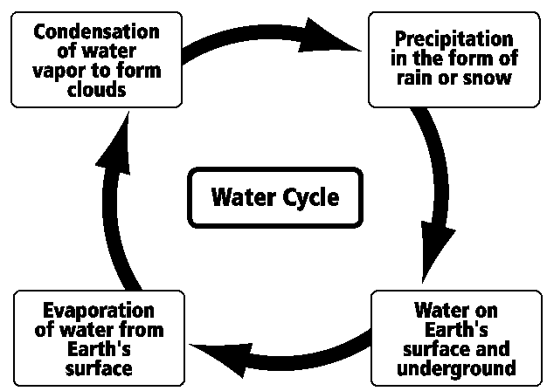

What type of model is shown in this image?

|  |  |
| --- | --- |
| A. | a scale model |
| B. | a physical model |
| C. | a conceptual model |
| D. | a mathematical model |

____ 4. What kind of model allows a scientist to understand a large object by studying the object at a smaller size?

|  |  |
| --- | --- |
| A. | a simulation |
| B. | a scale model |
| C. | a conceptual model |
| D. | a mathematical model |

____ 5. Which of the following best describes a typical disadvantage of using a mathematical model?

|  |  |
| --- | --- |
| A. | A mathematical model may be too dangerous or too expensive to study. |
| B. | A mathematical model may not behave exactly like the object it represents. |
| C. | A mathematical model may not be able to include certain ideas, which may lead to misconceptions about the system. |
| D. | A mathematical model may not include all the data, variables, and factors that lead to understanding a system or process fully. |

____ 6. The image below shows a type of model used by scientists.

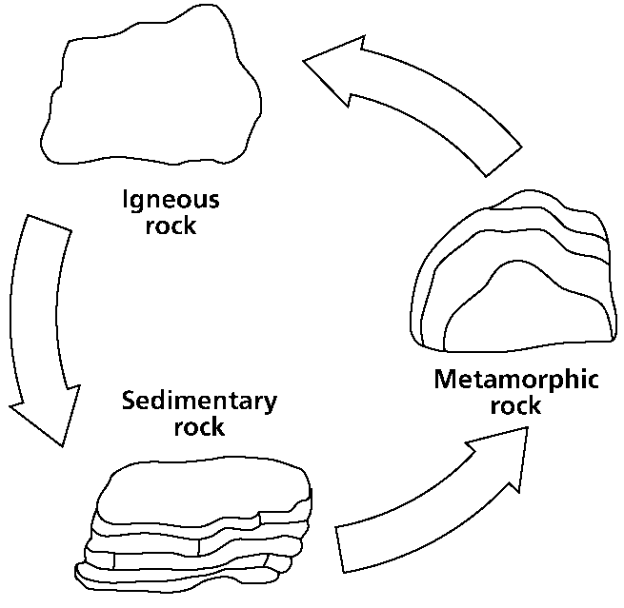

What type of model is shown in this image?

|  |  |
| --- | --- |
| A. | a scale model |
| B. | a physical model |
| C. | a conceptual model |
| D. | a mathematical model |

____ 7. What type of model often looks like, acts like, and copies the structure of the object it represents?

|  |  |
| --- | --- |
| A. | a simulation |
| B. | a physical model |
| C. | a conceptual model |
| D. | a mathematical model |

____ 8. According to Thomas Malthus, human population grows much faster than the production of food increases. What type of model would best represent this scenario?

|  |  |
| --- | --- |
| A. | a scale model |
| B. | a physical model |
| C. | a conceptual model |
| D. | a mathematical model |

____ 9. A graphic designer shows her plans for a new shopping mall by using a scale model of the actual mall. Why did the graphic designer most likely use a scale model and not another type of model?

|  |  |
| --- | --- |
| A. | She used a scale model because she wanted to show quantitative situations of shops. |
| B. | She used a scale model because she wanted to show something that is too large to see. |
| C. | She used a scale model because she wanted to show the patterns of behavior of shoppers. |
| D. | She used a scale model because she wanted to show a process that cannot be copied in real life. |

____ 10. What would scientists in 2010 most likely have used to project levels of atmospheric carbon dioxide between the years 2011 and 2100?

|  |  |
| --- | --- |
| A. | a model |
| B. | a prototype |
| C. | a simulation |
| D. | a probeware |

____ 11. How is a mathematical model most limited in its use?

|  |  |
| --- | --- |
| A. | It is limited by the existing data and variables. |
| B. | It is limited by ideas that can cause misconceptions. |
| C. | It is limited by the size of the object that is being modeled. |
| D. | It is limited by the model not behaving like the object it represents. |

____ 12. The executive board of a technological company wants to illustrate the task list for each of the different departments that make up the company. What type of model would best be used in this example?

|  |  |
| --- | --- |
| A. | a scale model |
| B. | a physical model |
| C. | a conceptual model |
| D. | a mathematical model |

____ 13. The figures below show how the model of the atom has changed over time.

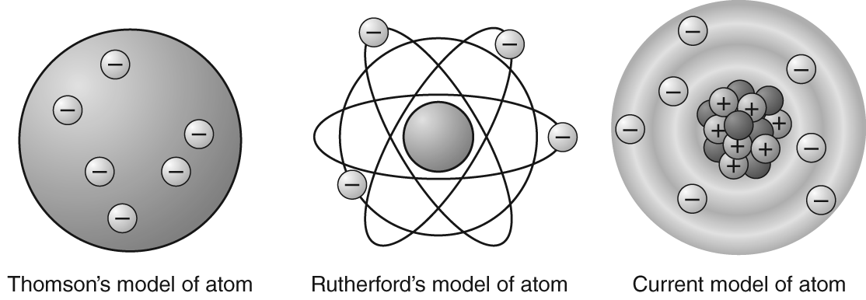

Which of the following statements bestexplains why these changes happened?

|  |  |
| --- | --- |
| A. | Scientists realized atoms were bigger then previously thought. |
| B. | Scientists realized atoms contain only one kind of particle at their centers. |
| C. | Scientists once thought positively charged particles orbit a negatively charged center, and later they reversed the picture. |
| D. | Scientists realized that all positive charge was located at the center of the atom and negatively charged particles, called *electrons*, moved about the center. |

____ 14. Which of the following would best be represented by a conceptual model?

|  |  |
| --- | --- |
| A. | a train |
| B. | a building |
| C. | the water cycle |
| D. | the formula for salt |

____ 15. A chemist uses a chemical formula to represent the reaction of two elements. What kind of model is the chemist using?

|  |  |
| --- | --- |
| A. | a scale model |
| B. | a physical model |
| C. | a conceptual model |
| D. | a mathematical model |

____ 16. Scientists use models and simulations in their work. Which one of the following does a simulation not do?

|  |  |
| --- | --- |
| A. | imitates the function of the thing it represents |
| B. | imitates the behavior of the thing it represents |
| C. | imitates the process of the thing it represents |
| D. | takes the place of the thing it represents |

____ 17. Look at the diagram below of the rock cycle.

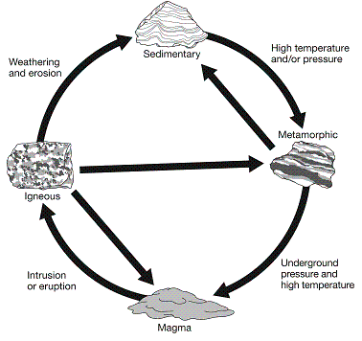

What does the diagram represent?

|  |  |
| --- | --- |
| A. | mathematical model |
| B. | simulation |
| C. | conceptual model |
| D. | physical model |

**Short Answer**

1. Below are two models of our solar system: the geocentric model at top and the heliocentric model at bottom.

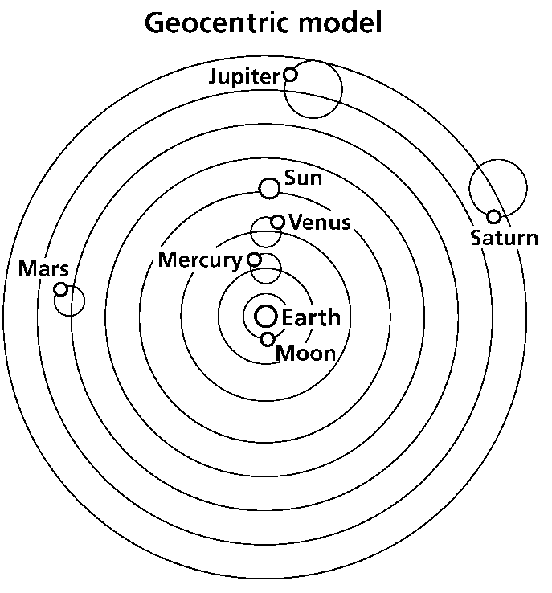

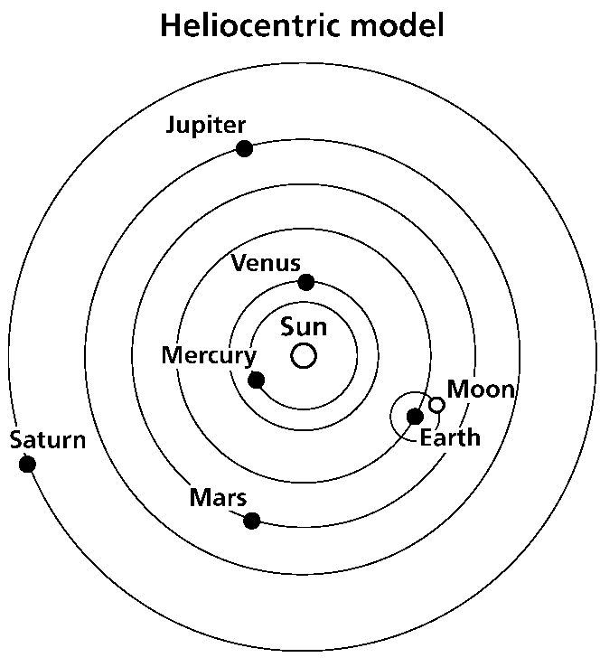

Briefly explain the differences between how the geocentric model and the heliocentric model explain the solar system.

___________________________________________________

___________________________________________________

___________________________________________________

**Essay**

1. Scientists are unsure exactly how much oil spilled into the Gulf of Mexico when an oil rig exploded in 2010. Some scientists estimated that thousands of barrels spilled, and some scientists estimated that millions of barrels spilled.

Why did scientists need to estimate the number of gallons that spilled into the Gulf?

___________________________________________________

___________________________________________________

What tool could scientists use to show where the oil spread?

___________________________________________________

How would a simulation help scientists to better understand the oil spill?

___________________________________________________

___________________________________________________

What limitations do all these tools have in terms of this oil spill?

___________________________________________________

___________________________________________________

**Other**

1. A toy car is an example of a ____________________ that represents a real car.

**Models and Simulations: PSSA Prep**

**Answer Section**

**MULTIPLE CHOICE**

1. ANS: B

A is incorrect because a system does not show what would happen in the case of a specific circumstance.

B is correct because a simulation imitates an event and shows how an event would occur under specific circumstances.

C is incorrect because a conceptual model represents how parts of a system are related or organized.

D is incorrect because a mathematical model is usually made up of numbers, equations, or other data.

PTS: 1

DIF: Bloom's Traditional: Evaluation | Bloom's Revised: Evaluating | Cognitive Complexity: High | Depth of Knowledge 3: Strategic Thinking | Student Level: Advanced

REF: 8936c270-fda6-11df-8e11-001e33aa91d2

OBJ: G6_NC_97126_ModelsAndSimulations

TOP: Models; simulations; introduction: Explain how scientists use models and simulations.

KEY: model | simulation MSC: Nature of Science | STEM | moduleK_u2_Lesson3 Quiz

2. ANS: D

A is incorrect because a toy car is a physical model of a real car.

B is incorrect because a miniature train is a tiny version of a real train.

C is incorrect because a stuffed animal is a toy version of the real organism.

D is correct because a chemical equation is a mathematical model.

PTS: 1

DIF: Bloom's Traditional: Analysis | Bloom's Revised: Analyzing | Cognitive Complexity: Moderate | Depth of Knowledge 3: Strategic Thinking | Student Level: Average

REF: 8939a8a0-fda6-11df-8e11-001e33aa91d2

OBJ: G6_NC_97126_ModelsAndSimulations

TOP: Models; physical: Identify an example of a physical model, and describe how it represents the natural world. KEY: physical model | mathematical model

MSC: Nature of Science | STEM | moduleK_u2_Lesson3 Quiz

3. ANS: C

A is incorrect because a scale model is a smaller version of a physical model.

B is incorrect because a physical model is a tangible model of some object.

C is correct because a conceptual model is a representation of how parts of a system are related or organized.

D is incorrect because a mathematical model would have numbers, equations, or other data.

PTS: 1

DIF: Bloom's Traditional: Application | Bloom's Revised: Applying | Cognitive Complexity: Moderate | Depth of Knowledge 2: Basic Application of Skill | Student Level: Average

REF: 893cb5e0-fda6-11df-8e11-001e33aa91d2

OBJ: G6_NC_97126_ModelsAndSimulations

TOP: Models; conceptual: Identify advantages and limitations of conceptual models.

KEY: conceptual model

MSC: Nature of Science | STEM | moduleK_u2_Lesson3 Quiz | STEM | Uses visual element

4. ANS: B

A is incorrect because a simulation imitates an event; it is not a model.

B is correct because a scale model is used to study objects that are too big or too small to see.

C is incorrect because a conceptual model deals with verbal or graphical explanations, not objects.

D is incorrect because a mathematical model deals with equations and quantitative processes.

PTS: 1

DIF: Bloom's Traditional: Knowledge | Bloom's Revised: Remembering | Cognitive Complexity: Low | Depth of Knowledge 1: Recall | Student Level: Basic

REF: 89431e80-fda6-11df-8e11-001e33aa91d2

OBJ: G6_NC_97126_ModelsAndSimulations

TOP: Models; physical: Explain how scale models can be used.

KEY: physical model | scale MSC: Nature of Science | STEM | moduleK_u2_Lesson3 Quiz

5. ANS: D

A is incorrect because this answer describes why a physical model is used.

B is incorrect because this answer describes the limitations of a physical model (objects).

C is incorrect because this answer describes the limitations of a conceptual model (ideas)

D is correct because this answer describes the limitations of a mathematical model (data, variables, and factors).

PTS: 1

DIF: Bloom's Traditional: Comprehension | Bloom's Revised: Understanding | Cognitive Complexity: Low | Depth of Knowledge 2: Basic Application of Skill | Student Level: Basic

REF: 893fc320-fda6-11df-8e11-001e33aa91d2

OBJ: G6_NC_97126_ModelsAndSimulations

TOP: Models; mathematical: Identify advantages and limitations of mathematical models.

KEY: mathematical model | limitation MSC: Nature of Science | STEM | moduleK_u2_Lesson3 Quiz

6. ANS: C

A is incorrect because a scale model is a type of physical model that represents a real-life object.

B is incorrect because a physical model is a physical object.

C is correct because this is a diagram of the rock cycle, a conceptual model.

D is incorrect because a mathematical model is usually a formula or an equation.

PTS: 1

DIF: Bloom's Traditional: Comprehension | Bloom's Revised: Understanding | Cognitive Complexity: Low | Depth of Knowledge 2: Basic Application of Skill | Student Level: Basic

REF: 8a5e0460-fda6-11df-8e11-001e33aa91d2

OBJ: G6_NC_97126_ModelsAndSimulations

TOP: Models; conceptual: Identify an example of a conceptual model, and explain how it represents the natural world. KEY: conceptual model

MSC: Uses visual element | Nature of Science | STEM | moduleK_u2 Pretest

7. ANS: B

A is incorrect because a simulation is not a model.

B is correct because a physical model is an object and often looks and acts like the object it represents.

C is incorrect because a structure is a physical object, not a conceptual one.

D is incorrect because a structure is a physical object, not a mathematical one.

PTS: 1

DIF: Bloom's Traditional: Knowledge | Bloom's Revised: Remembering | Cognitive Complexity: Low | Depth of Knowledge 1: Recall | Student Level: Basic

REF: 8a615fc0-fda6-11df-8e11-001e33aa91d2

OBJ: G6_NC_97126_ModelsAndSimulations

TOP: Models; physical: Identify an example of a physical model, and describe how it represents the natural world. KEY: physical model MSC: Nature of Science | STEM | moduleK_u2 Pretest

8. ANS: D

A is incorrect because a scale model would not show growth.

B is incorrect because a physical model would not be the best tool to contrast two different growth rates.

C is incorrect because a conceptual model would not be the best tool to contrast two different growth rates.

D is correct because the problem concerns mathematical concepts, or growth rates, so a mathematical model would be the best model to use.

PTS: 1

DIF: Bloom's Traditional: Evaluation | Bloom's Revised: Evaluating | Cognitive Complexity: High | Depth of Knowledge 3: Strategic Thinking | Student Level: Advanced

REF: 8a6445f0-fda6-11df-8e11-001e33aa91d2

OBJ: G6_NC_97126_ModelsAndSimulations

TOP: Models; mathematical: Identify an example of a mathematical model, and describe how it represents the natural world. KEY: mathematical model

MSC: Nature of Science | STEM | moduleK_u2 Pretest

9. ANS: B

A is incorrect because quantitative situations are an advantage of using a mathematical model.

B is correct because a scale model is a type of physical model, and a scale model is appropriate because a shopping mall is too large to see otherwise.

C is incorrect because patterns of behavior are an advantage of using a mathematical model.

D is incorrect because a conceptual model is appropriate for an abstract process that cannot be studied directly.

PTS: 1

DIF: Bloom's Traditional: Analysis | Bloom's Revised: Analyzing | Cognitive Complexity: Moderate | Depth of Knowledge 3: Strategic Thinking | Student Level: Average

REF: 8b8609a0-fda6-11df-8e11-001e33aa91d2

OBJ: G6_NC_97126_ModelsAndSimulations

TOP: Models; physical: Explain how scale models can be used.

KEY: scale | physical model MSC: Nature of Science | STEM | moduleK_u2 Unit Test A

10. ANS: C

A is incorrect because a model represents something; it is not a method for predicting the future.

B is incorrect because a prototype cannot predict the future of an event.

C is correct because a simulation is an imitation of a function, process, or process (in this case, rising levels of atmospheric CO2). A simulation can also be used to predict future events.

D is incorrect because probeware allows scientists to collect, interpret, and analyze data, not necessarily predict a future outcome of a current event.

PTS: 1

DIF: Bloom's Traditional: Evaluation | Bloom's Revised: Evaluating | Cognitive Complexity: High | Depth of Knowledge 3: Strategic Thinking | Student Level: Advanced

REF: 8a80f5b0-fda6-11df-8e11-001e33aa91d2

OBJ: G6_NC_97126_ModelsAndSimulations

TOP: Models; simulations; introduction: Explain how scientists use models and simulations.

KEY: simulation | model MSC: Nature of Science | STEM | moduleK_u2 Pretest

11. ANS: A

A is correct because data and variables are a limitation of mathematical models.

B is incorrect because ideas are a limitation of conceptual models.

C is incorrect because size limitations can affect physical models.

D is incorrect because a model not behaving like it should is a limitation of physical models.

PTS: 1

DIF: Bloom's Traditional: Knowledge | Bloom's Revised: Remembering | Cognitive Complexity: Low | Depth of Knowledge 1: Recall | Student Level: Basic

REF: 8ba97020-fda6-11df-8e11-001e33aa91d2

OBJ: G6_NC_97126_ModelsAndSimulations

TOP: Models; mathematical: Identify advantages and limitations of mathematical models.

KEY: physical model | limitation MSC: Nature of Science | STEM | moduleK_u2 Unit Test B

12. ANS: C

A is incorrect because a scale model is appropriate for physical objects. The board is working with a set of tasks or processes.

B is incorrect because a physical model is appropriate for physical objects. The board is working with a set of tasks or processes.

C is correct because a conceptual model is a drawing or a diagram of a process. The board is working with a set of tasks or processes, so a conceptual model is most appropriate.

B is incorrect because a mathematical model is appropriate for numbers. The board is working with a set of tasks or processes.

PTS: 1

DIF: Bloom's Traditional: Analysis | Bloom's Revised: Analyzing | Cognitive Complexity: Moderate | Depth of Knowledge 3: Strategic Thinking | Student Level: Average

REF: 8a777fd0-fda6-11df-8e11-001e33aa91d2

OBJ: G6_NC_97126_ModelsAndSimulations

TOP: Models; conceptual: Identify an example of a conceptual model, and explain how it represents the natural world. KEY: conceptual model

MSC: Nature of Science | STEM | moduleK_u2 Unit Test B

13. ANS: D

A is incorrect because none of the models implies bigger or smaller atoms.

B is incorrect because the current model of the atom shows several different kinds of particles in the atom’s center.

C is incorrect because no model shows positively charged particles moving about a negatively charged center.

D is correct because as scientists learned more about atoms, they discovered that atoms had positively charged centers that were surrounded by clouds of electrons.

PTS: 1

DIF: Bloom's Traditional: Evaluation | Bloom's Revised: Evaluating | Cognitive Complexity: High | Depth of Knowledge 3: Strategic Thinking | Student Level: Advanced

REF: 8a0f9640-fda6-11df-8e11-001e33aa91d2

OBJ: G6_NC_97126_ModelsAndSimulations

TOP: Models; simulations; introduction: Explain how models change as scientific knowledge changes.

KEY: atomic model | scientific knowledge | atom | Rutherford | Thompson

MSC: Uses visual element | Nature of Science | STEM | moduleK_Module Review

14. ANS: C

A is incorrect because a train would best be represented by a physical model.

B is incorrect because a building would best be represented by a scale model.

C is correct because the water cycle would best be represented by a conceptual model such as a diagram.

D is incorrect because a formula would best be represented by a mathematical model.

PTS: 1

DIF: Bloom's Traditional: Comprehension | Bloom's Revised: Understanding | Cognitive Complexity: Low | Depth of Knowledge 2: Basic Application of Skill | Student Level: Basic

REF: 8a7adb30-fda6-11df-8e11-001e33aa91d2

OBJ: G6_NC_97126_ModelsAndSimulations

TOP: Models; conceptual: Identify an example of a conceptual model, and explain how it represents the natural world. KEY: conceptual model

MSC: Nature of Science | STEM | moduleK_Module Review

15. ANS: D

A is incorrect because a chemical formula uses numbers, letters, and mathematical symbols to represent a chemical reaction.

B is incorrect because a chemical formula uses numbers, letters, and mathematical symbols to represent a chemical reaction.

C is incorrect because a chemical formula uses numbers, letters, and mathematical symbols to represent a chemical reaction.

D is correct because a chemical formula uses numbers, letters, and mathematical symbols to represent a chemical reaction.

PTS: 1

DIF: Bloom's Traditional: Comprehension | Bloom's Revised: Understanding | Cognitive Complexity: Low | Depth of Knowledge 2: Basic Application of Skill | Student Level: Basic

REF: 8a7de870-fda6-11df-8e11-001e33aa91d2

OBJ: G6_NC_97126_ModelsAndSimulations

TOP: Models; mathematical: Identify an example of a mathematical model, and describe how it represents the natural world. KEY: mathematical model

MSC: Nature of Science | STEM | moduleK_Module Review

16. ANS: D

A is incorrect because simulations imitate the function of the thing it is representing.

B is incorrect because a simulation imitates the behavior of whatever it is representing.

C is incorrect because a simulation imitates the process of what it is representing.

D is correct because the simulation cannot take the place of the process or thing it represents.

PTS: 1

DIF: Bloom's Traditional: Application | Bloom's Revised: Applying | Cognitive Complexity: Moderate | Depth of Knowledge 3: Strategic Thinking | Student Level: Average

OBJ: G6_NC_97126_ModelsAndSimulations

TOP: Models; simulations: Explain how scientists use models and simulations.

KEY: simulation | model | imitation MSC: moduleK_u2 Unit Review | Nature of Science

17. ANS: C

A is incorrect because a mathematical model is usually made up of numbers, equations or other forms of data.

B is incorrect because a simulation would imitate the function, and this simply gives a picture of the process.

C is correct because the rock cycle is a conceptual model of how parts of a system are related or organized.

D is incorrect because a physical model represents the physical structure of a system, and the diagram does not do this.

PTS: 1

DIF: Bloom's Traditional: Analysis | Bloom's Revised: Analyzing | Cognitive Complexity: Moderate | Depth of Knowledge 2: Basic Application of Skill | Student Level: Average

OBJ: G6_NC_97126_ModelsAndSimulations

TOP: Models; conceptual: Identify an example of a conceptual model, and explain how it represents the natural world. KEY: model | conceptual model

MSC: moduleK_u2 Unit Review | Nature of Science | Uses visual element

**SHORT ANSWER**

1. ANS:

• description of geocentric model (e.g., *The geocentric model shows the other planets and the sun rotating around Earth*; etc.)

• description of heliocentric model (e.g., *The heliocentric model shows Earth and the other planets rotating about the sun*; etc.)

PTS: 2

DIF: Bloom's Traditional: Analysis | Bloom's Revised: Analyzing | Cognitive Complexity: Moderate | Depth of Knowledge 3: Strategic Thinking | Student Level: Average

REF: 8bc3fd00-fda6-11df-8e11-001e33aa91d2

OBJ: G6_NC_97126_ModelsAndSimulations

TOP: Models; simulations; introduction: Explain how models change as scientific knowledge changes.

KEY: model | representation | evidence

MSC: Uses visual element | Nature of Science | STEM | moduleK_u2 Unit Test A

**ESSAY**

1. ANS:

• explanation of why an estimate was necessary (e.g., *Scientists estimated the gallons of oil spilled because it is not feasible to get an accurate measure in such a large body of water; Different groups of scientists used different tools; New observations were introduced into the data at different times*; etc.)

• a computer

• explanation of how a simulation would be useful (e.g., *A simulation would show how the oil spread initially; a simulation would predict how the oil might spread in the future*; etc.)

• description of limitations of tools to study oil spill (e.g., *Scientists are limited because these tools cannot measure the exact volume of oil spilled; these tools cannot reproduce everything about the oil spill; when dealing with a fluid substance such as water, tools can often have errors because things change so abruptly*; etc.)

PTS: 4

DIF: Bloom's Traditional: Evaluation | Bloom's Revised: Evaluating | Cognitive Complexity: High | Depth of Knowledge 4: Extended Thinking | Student Level: Advanced

REF: 8ab0df50-fda6-11df-8e11-001e33aa91d2

OBJ: G6_NC_97126_ModelsAndSimulations

TOP: Models; simulations; introduction: Explain how models change as scientific knowledge changes. | Models; simulations; introduction: Explain how scientists use models and simulations.

KEY: tool | investigation | science | computer | simulation | model

MSC: Nature of Science | STEM | moduleK_u2 Unit Test A

**OTHER**

1. ANS:

Rationale: A physical model represents the physical structure of an object or system.

PTS: 2

DIF: Bloom's Traditional: Comprehension | Bloom's Revised: Understanding | Cognitive Complexity: Low | Depth of Knowledge 1: Recall | Student Level: Basic

OBJ: G6_NC_97126_ModelsAndSimulations

TOP: Models; physical: Identify an example of a physical model, and describe how it represents the natural world. KEY: physical model | model

MSC: moduleK_u2 Unit Review | Nature of Science